**Kushagra Rastogi**

**304640248**

**ECE 219**

**Project 4: Regression Analysis**

**DATASET 1**

**QUESTION 1:**

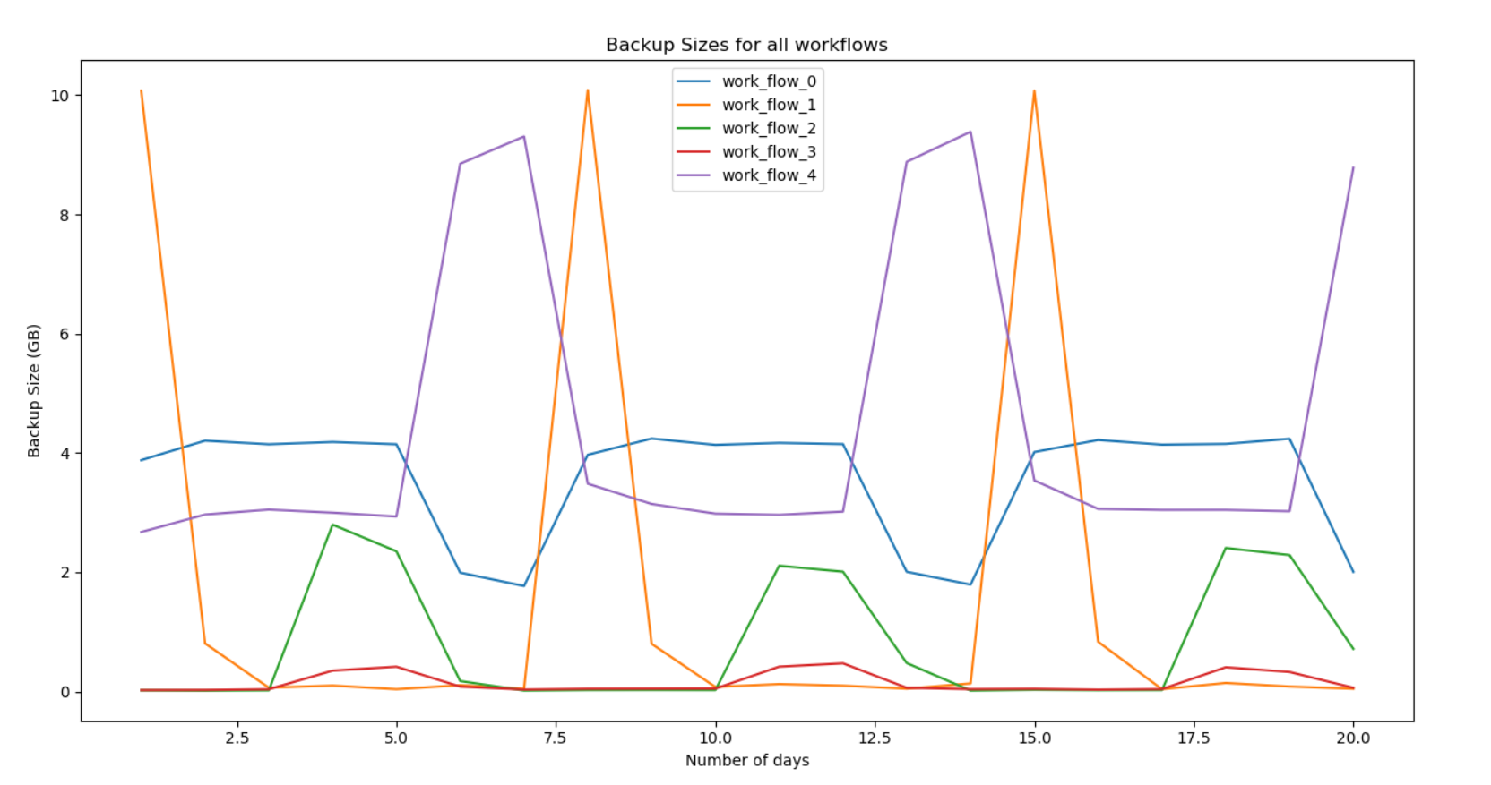

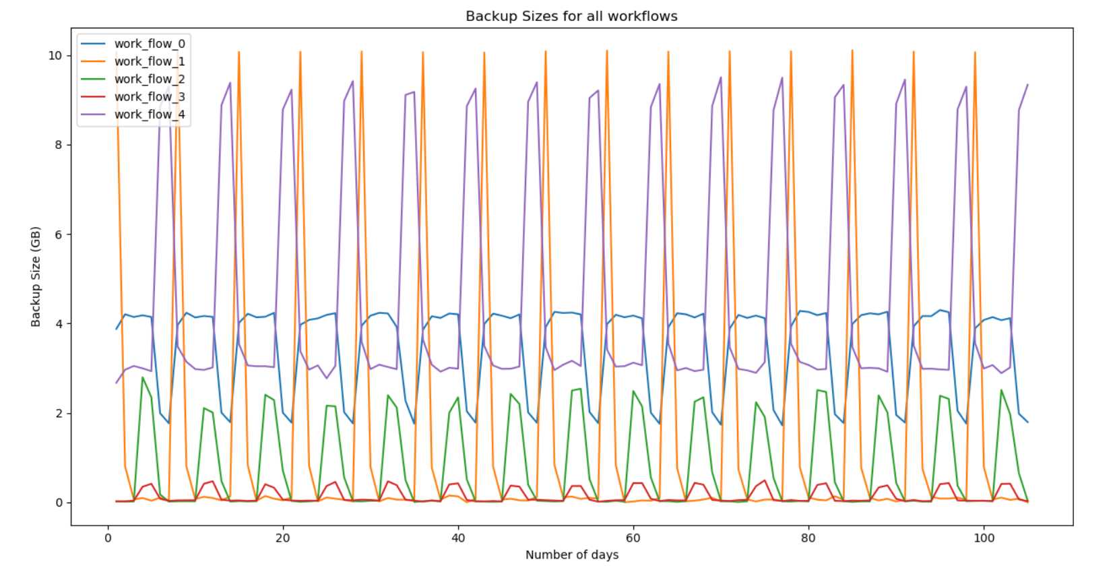

All the workflows in the dataset follow a pattern. The pattern is the same every week. The pattern is different for each workflow.

**QUESTION 2:**

1. Linear Regression

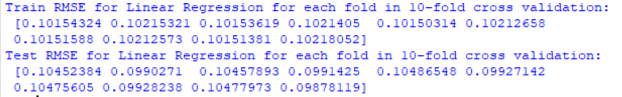

I will use the Test RMSE to determine which is the best estimator. The lowest Test RMSE occurs at fold = 10. Thus, I will choose the estimator that was trained in that fold.

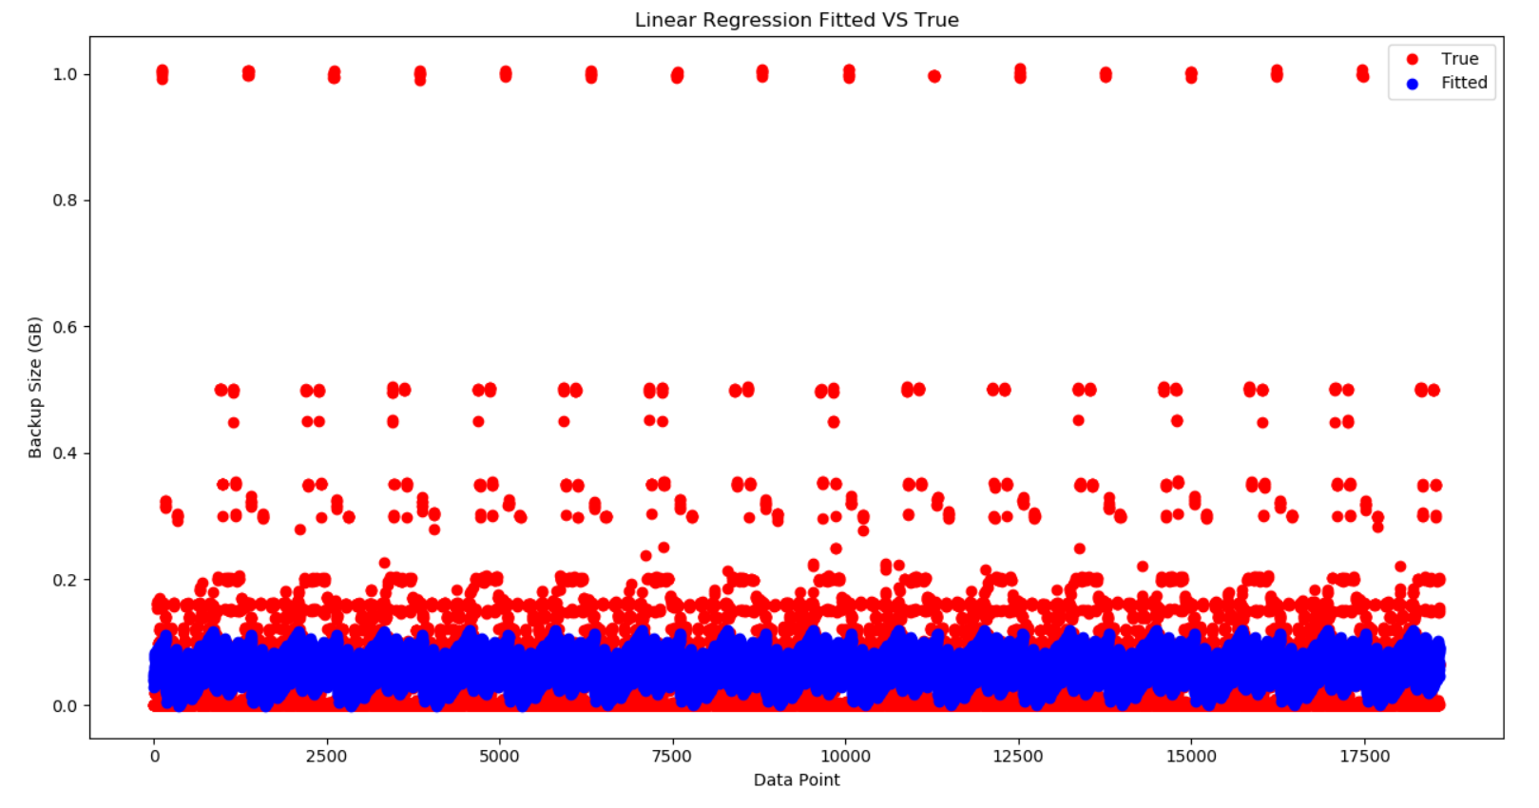

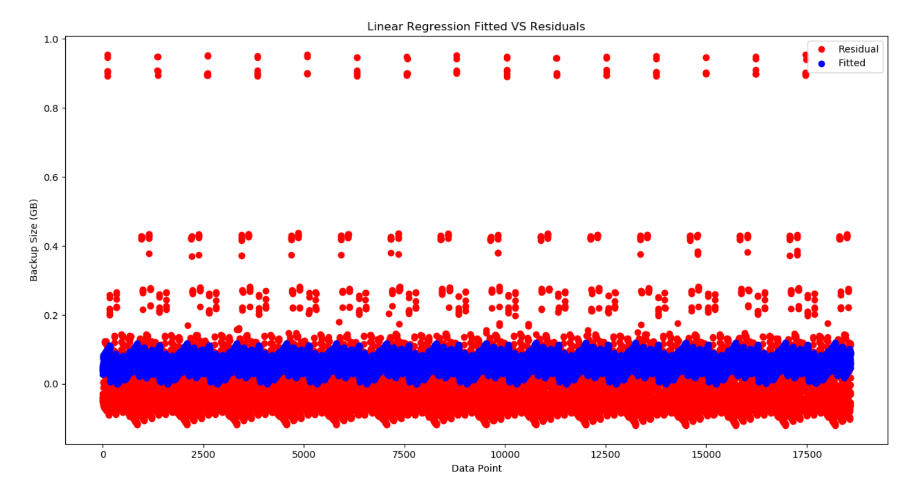

1. Random Forest

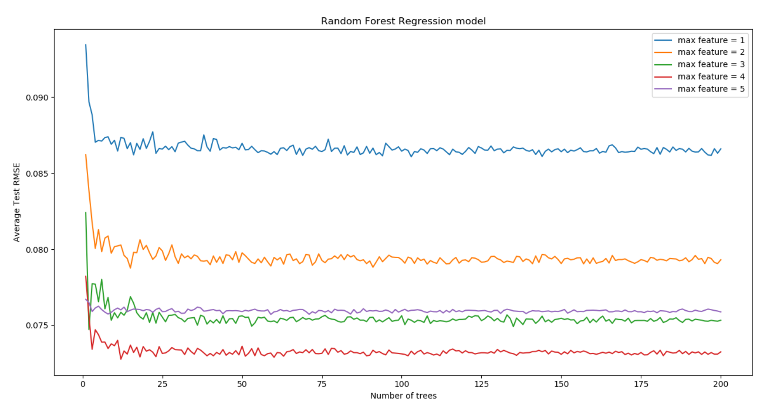

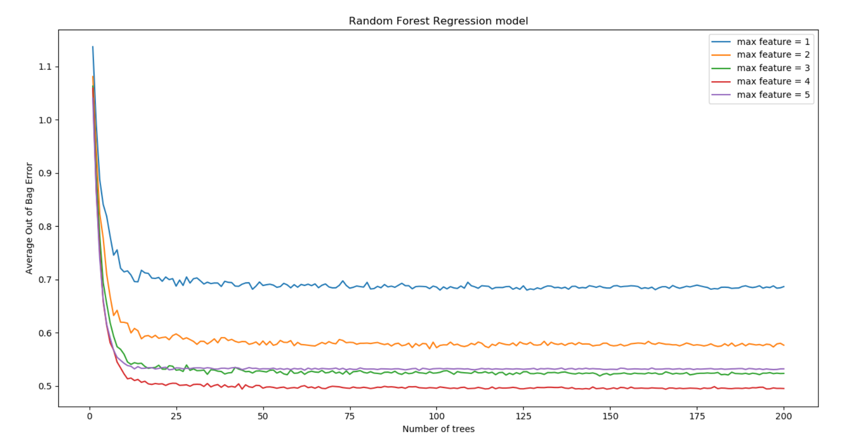

The Out of Bag error is greater than 1 because $Out of Bag error=1-Out of Bag score$. Since $-1≤Out of Bag score≤1$, Out of Bag error can be greater than 1.

Although Test RMSE is a good metric to use when looking for best parameters, the Out of Bag error is a unique metric that can be used to used to especially evaluate a random forest’s performance. Using Out of Bag error, the best parameters are number of trees = 166 and max features = 4.

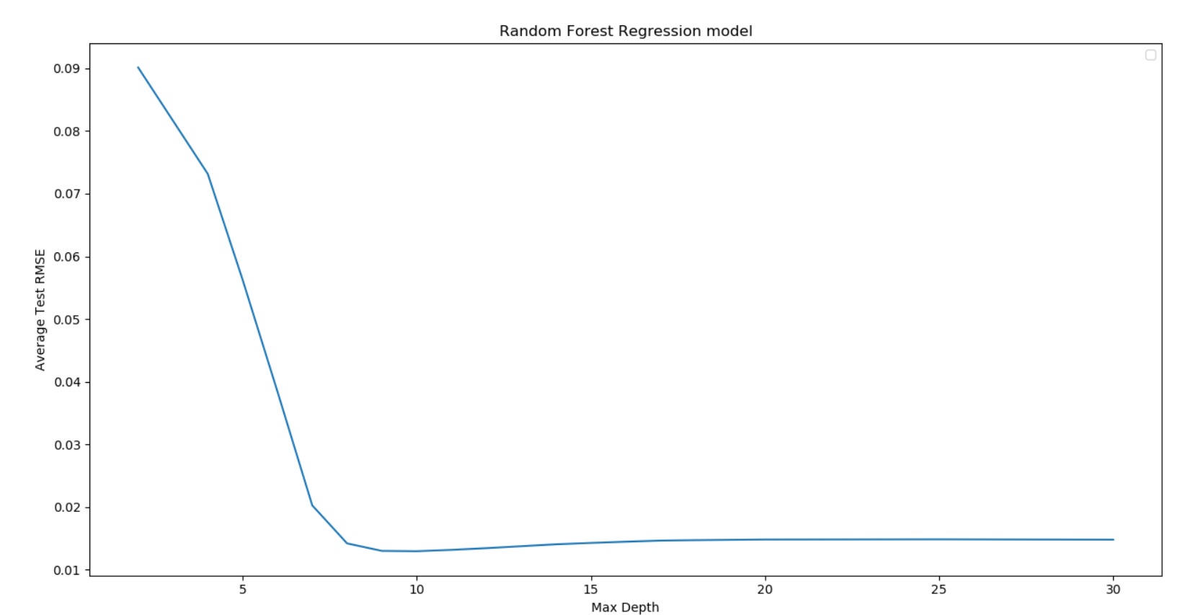

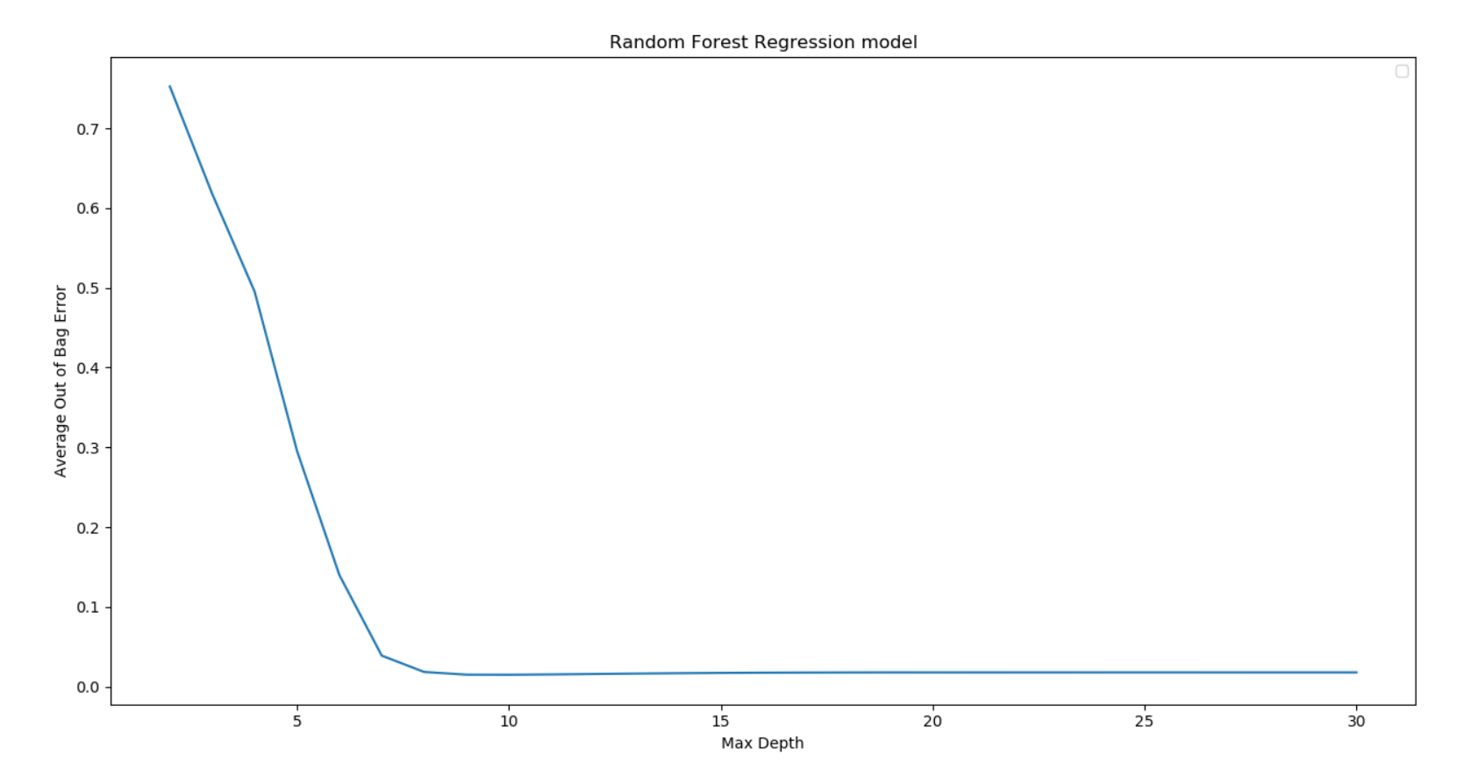

It can be seen that when max depth = 10, the performance is the best. The random forest starts to overfit since the average test RMSE increases when max depth > 10. Thus, the best parameters are max depth= 10, number of trees = 166 and max features = 4.



From the values above, the two most important features are ‘Day of Week’ and ‘Backup Start Time’.

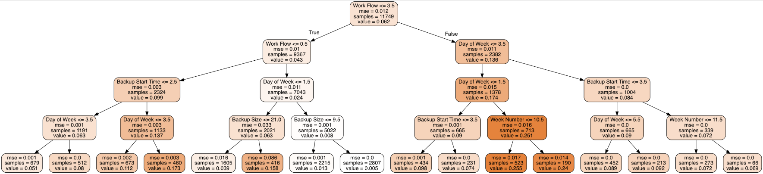

The root node of the decision tree is the Workflow feature. This is not the most important feature. This can be explained because the best random forest model had parameters of number of trees = 166, max features = 4 and max depth = 10. However, the specifications ask for a best random forest with max depth = 4, the parameters used for this model are not optimal. Thus, feature importance for this model is different than the feature important of the model with max depth = 10.

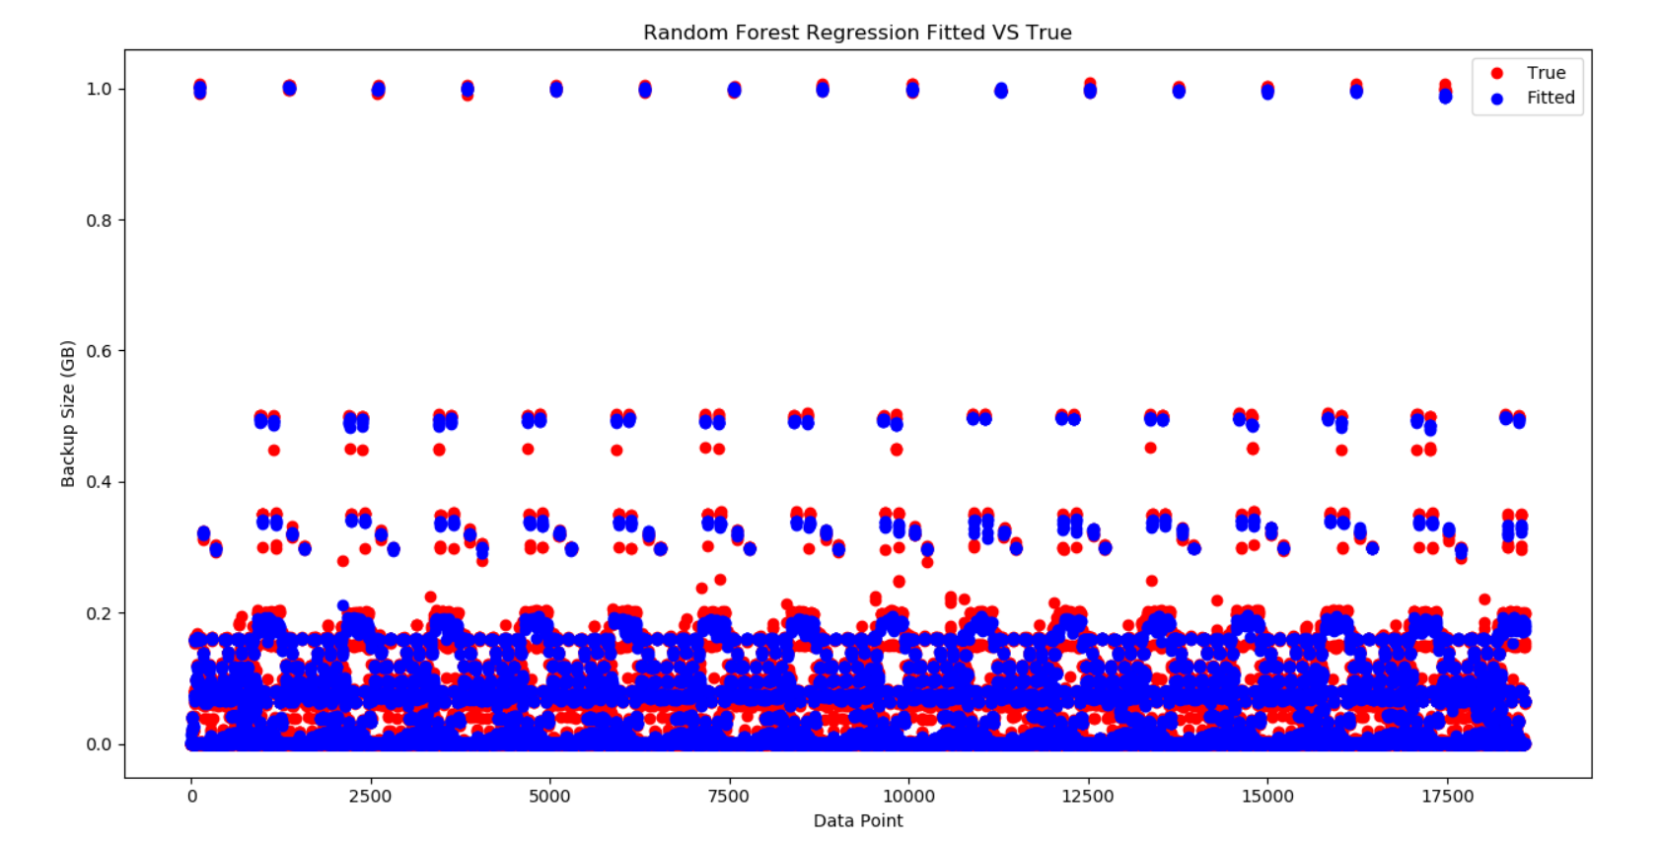

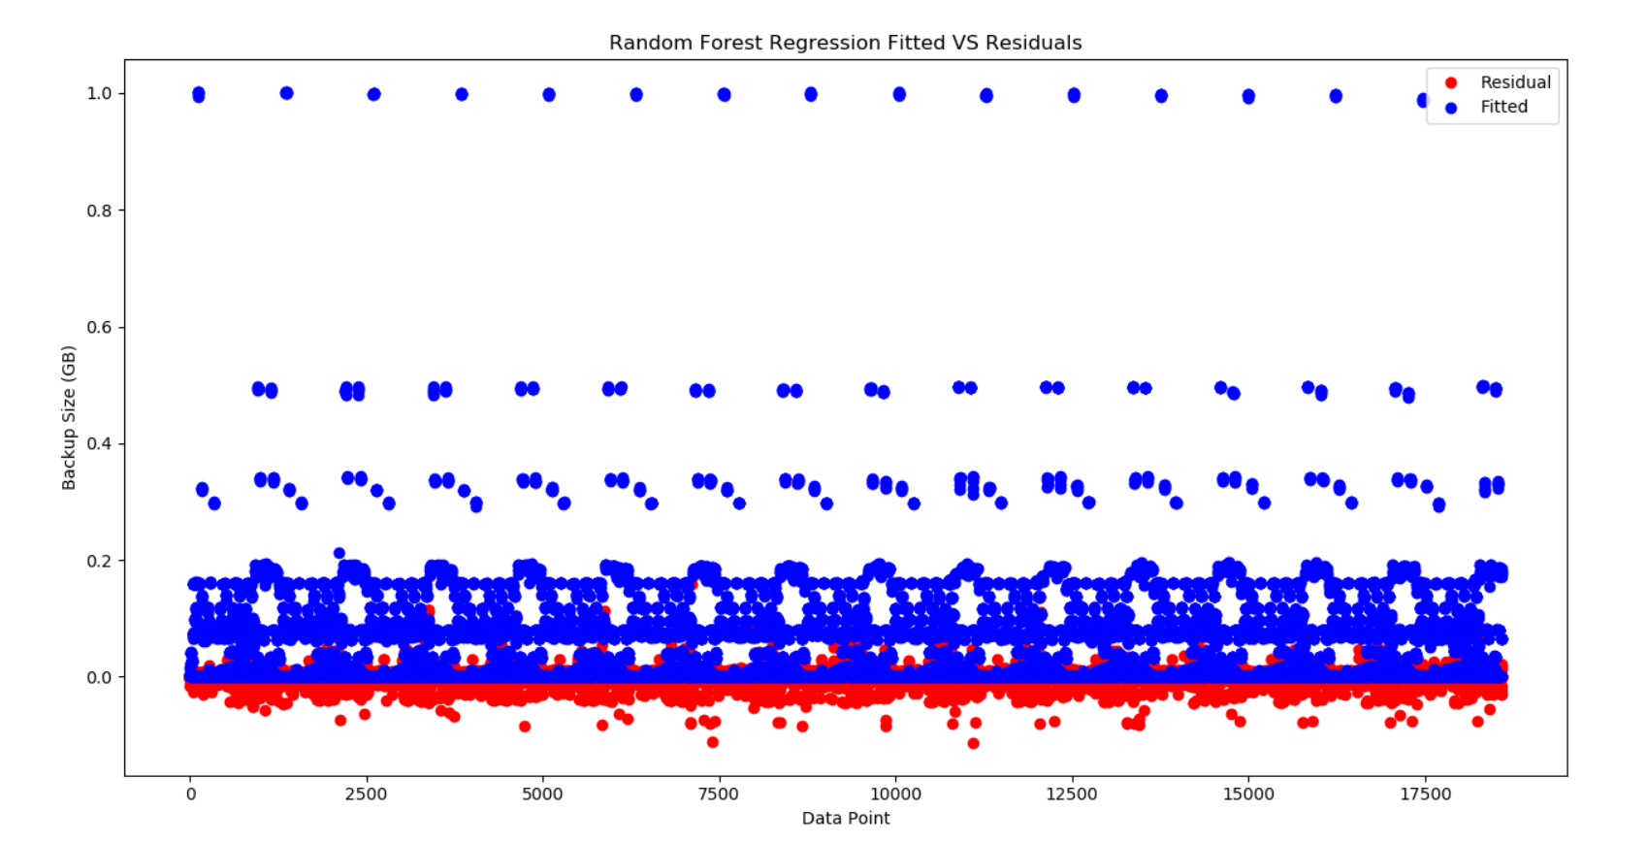

1. Neural Network

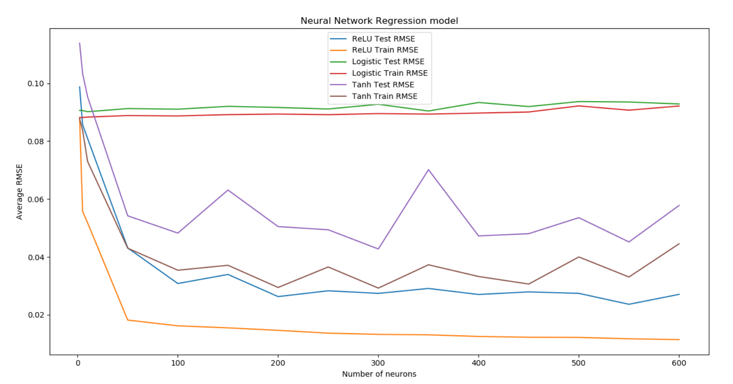

The best combination is 200 neurons with a ReLU activation function.

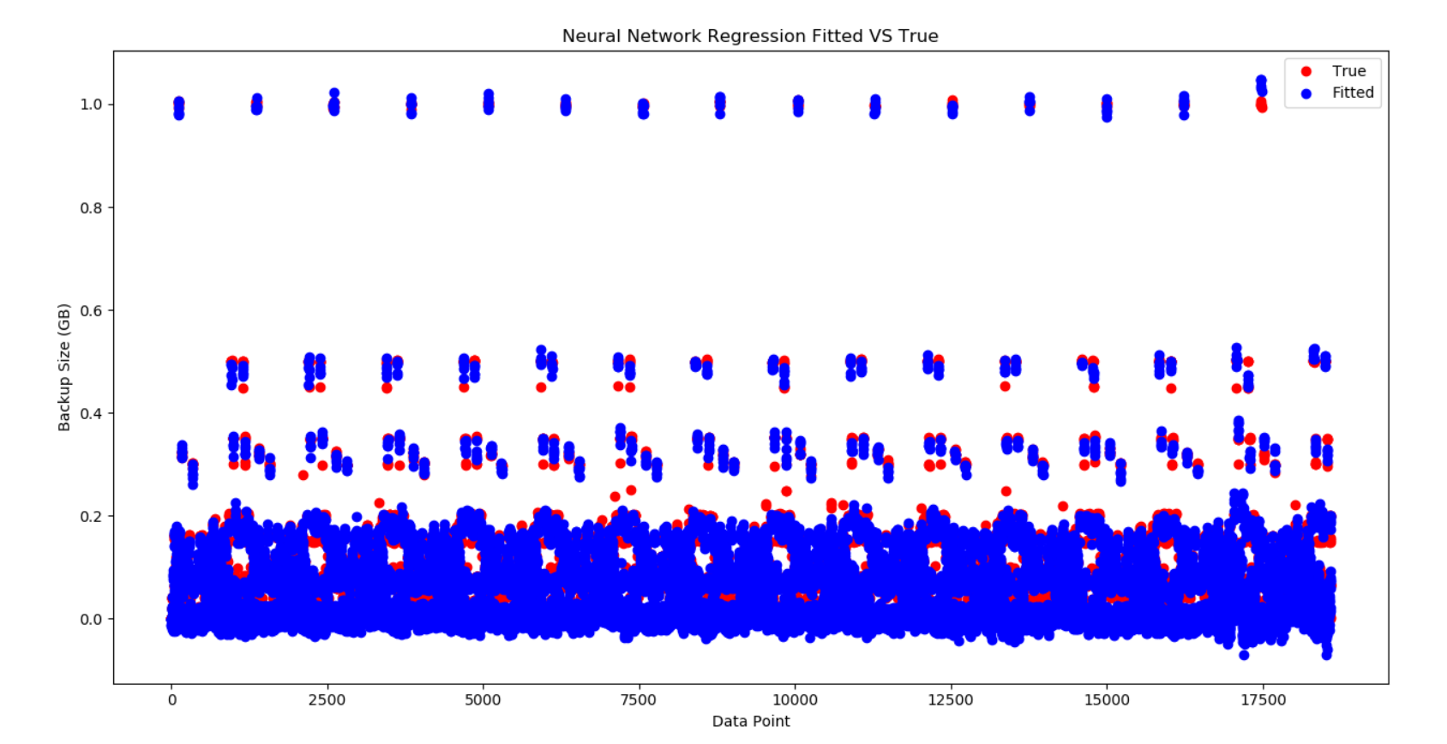

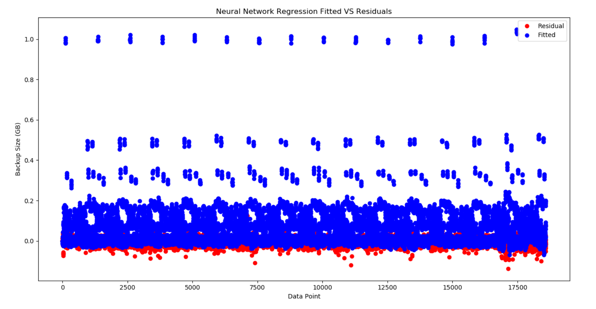

1. Predict Backup size for each workflow separately

The fit is improved because the model is trying to learn from a smaller subset of the data. This allows the model to capture the variance and information of the data more accurately.

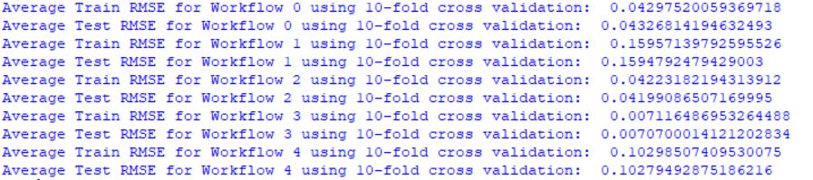

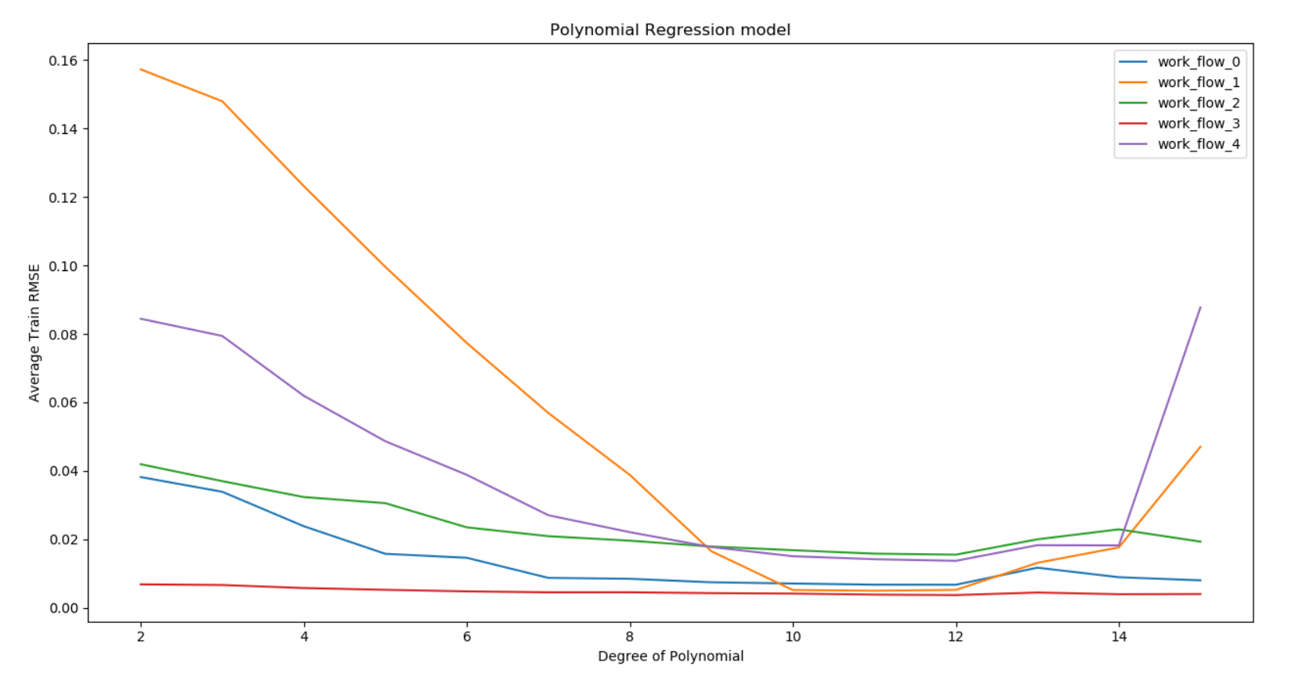

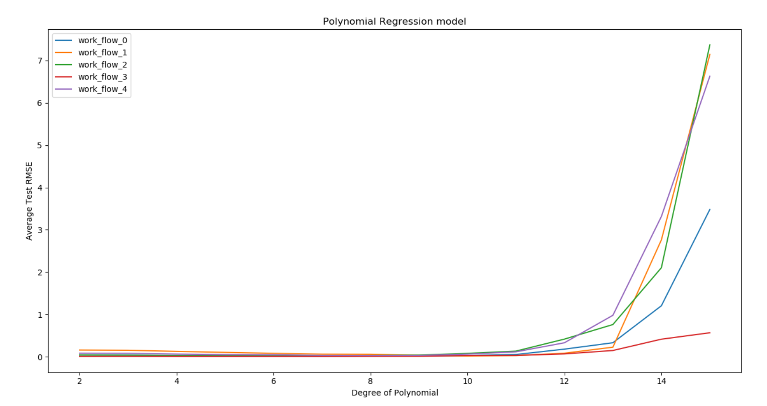

The generalization error can be deduced from the test RMSE. After the degree of the polynomial exceeds 10, the error starts to rise. Thus, degree = 10 is the threshold.

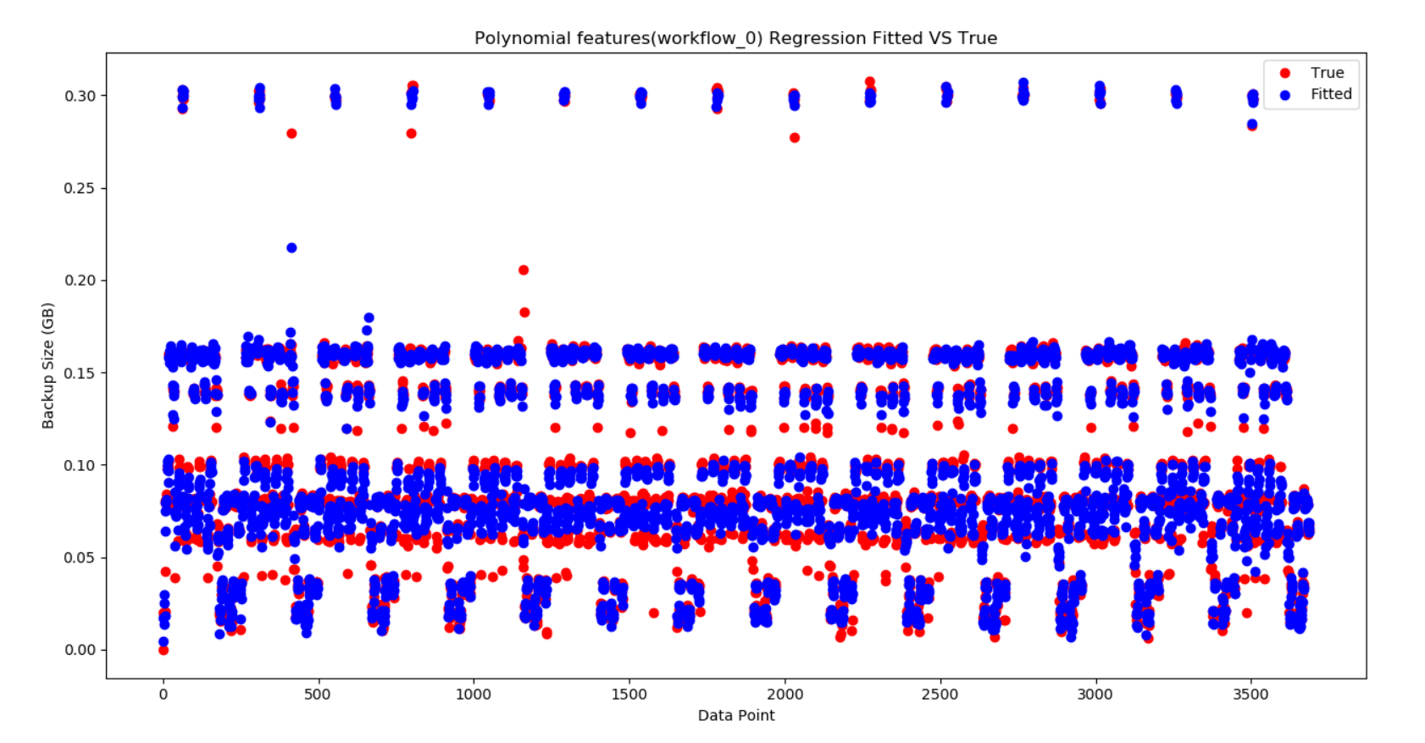

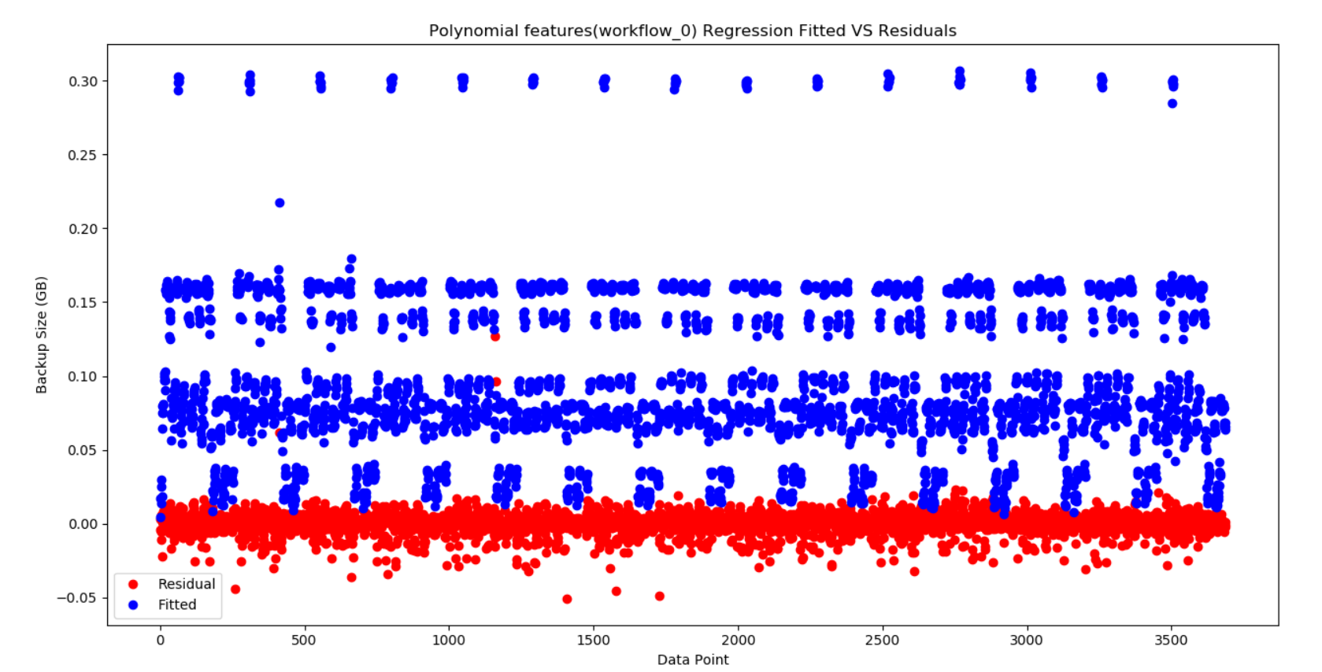

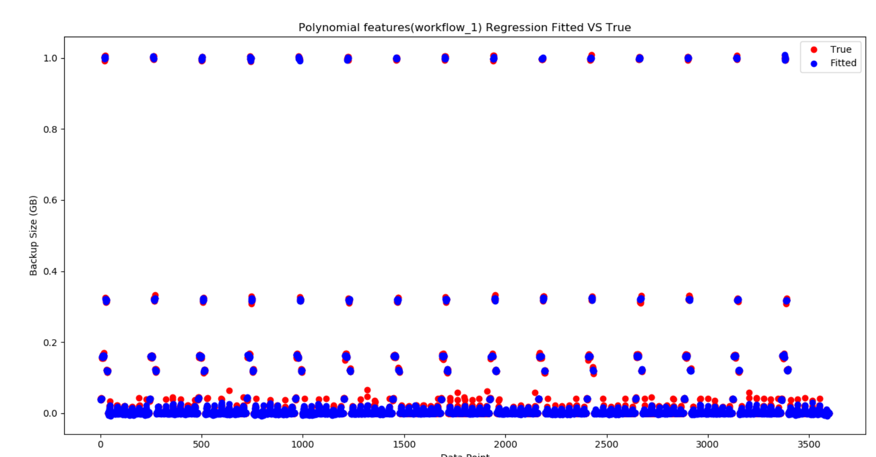

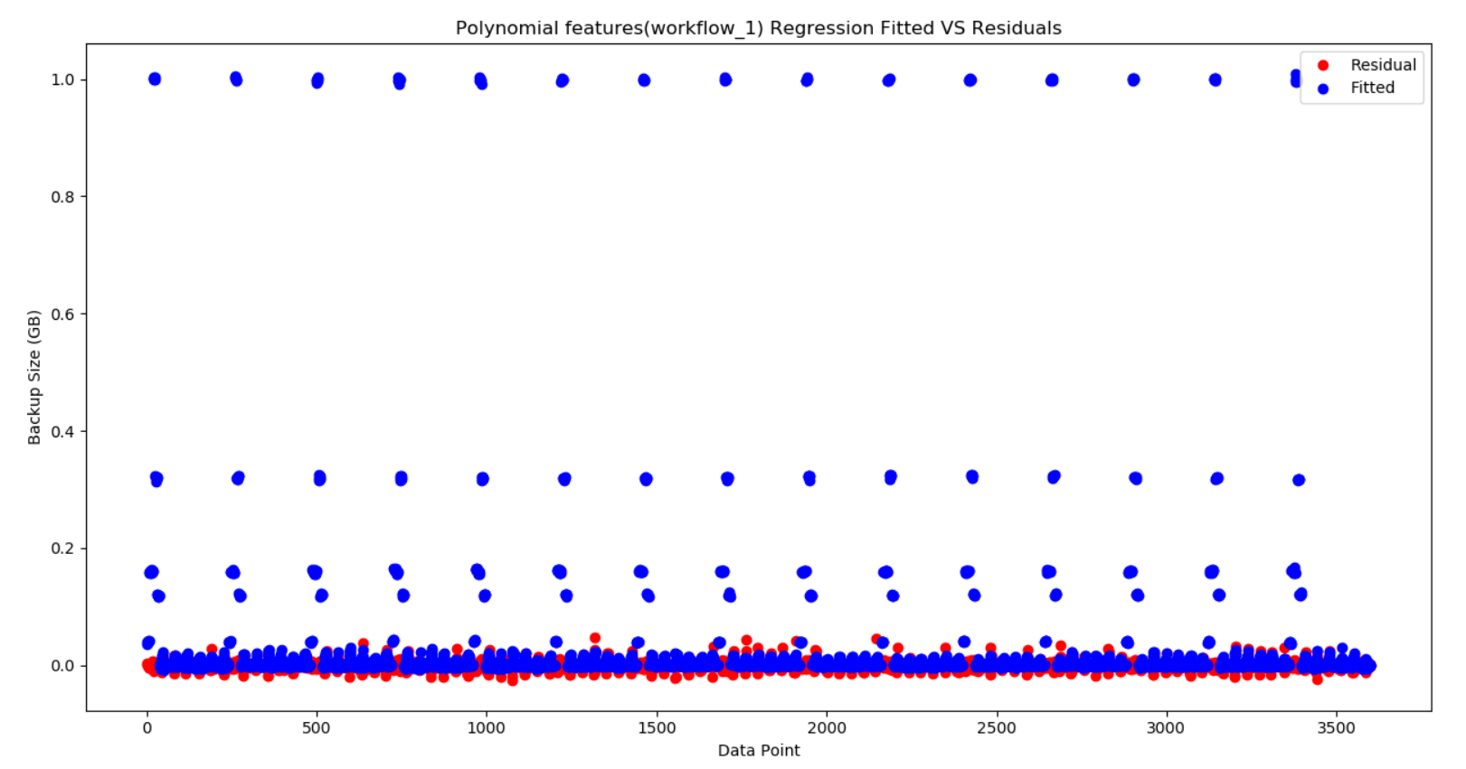

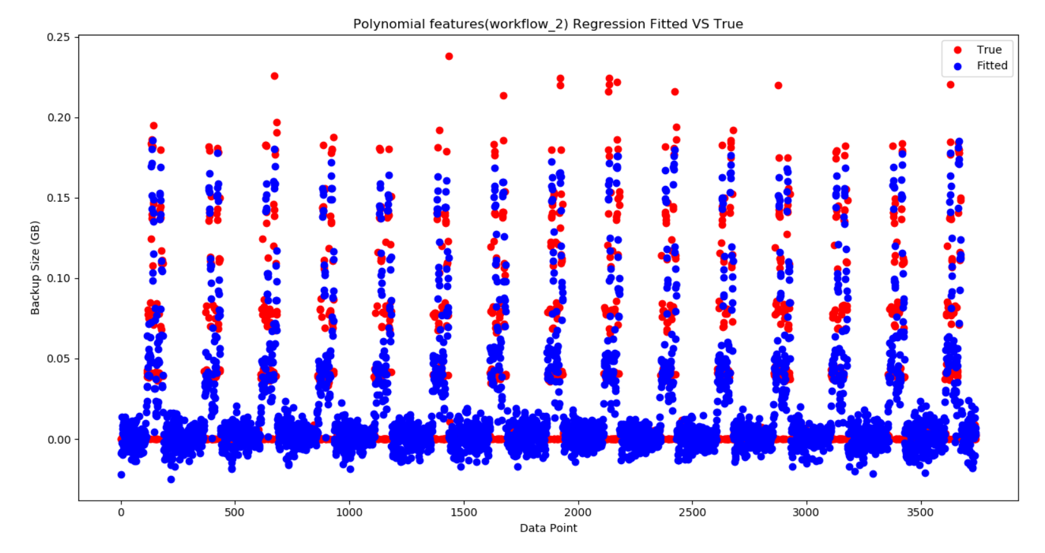

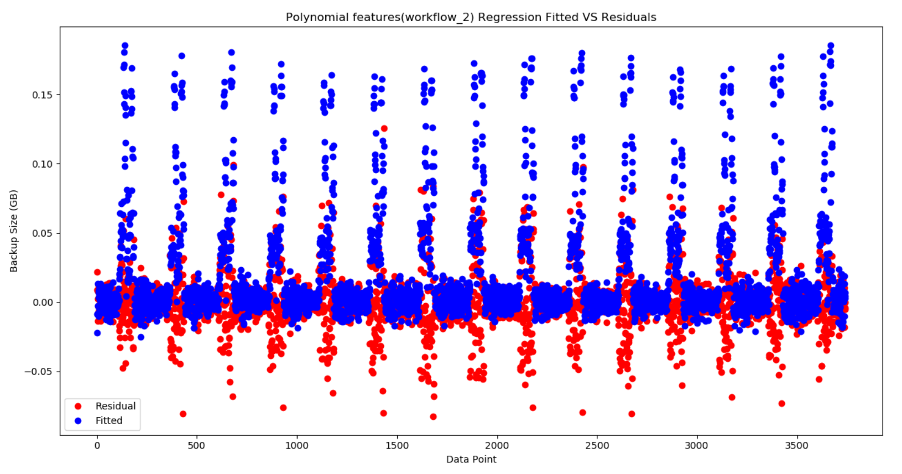

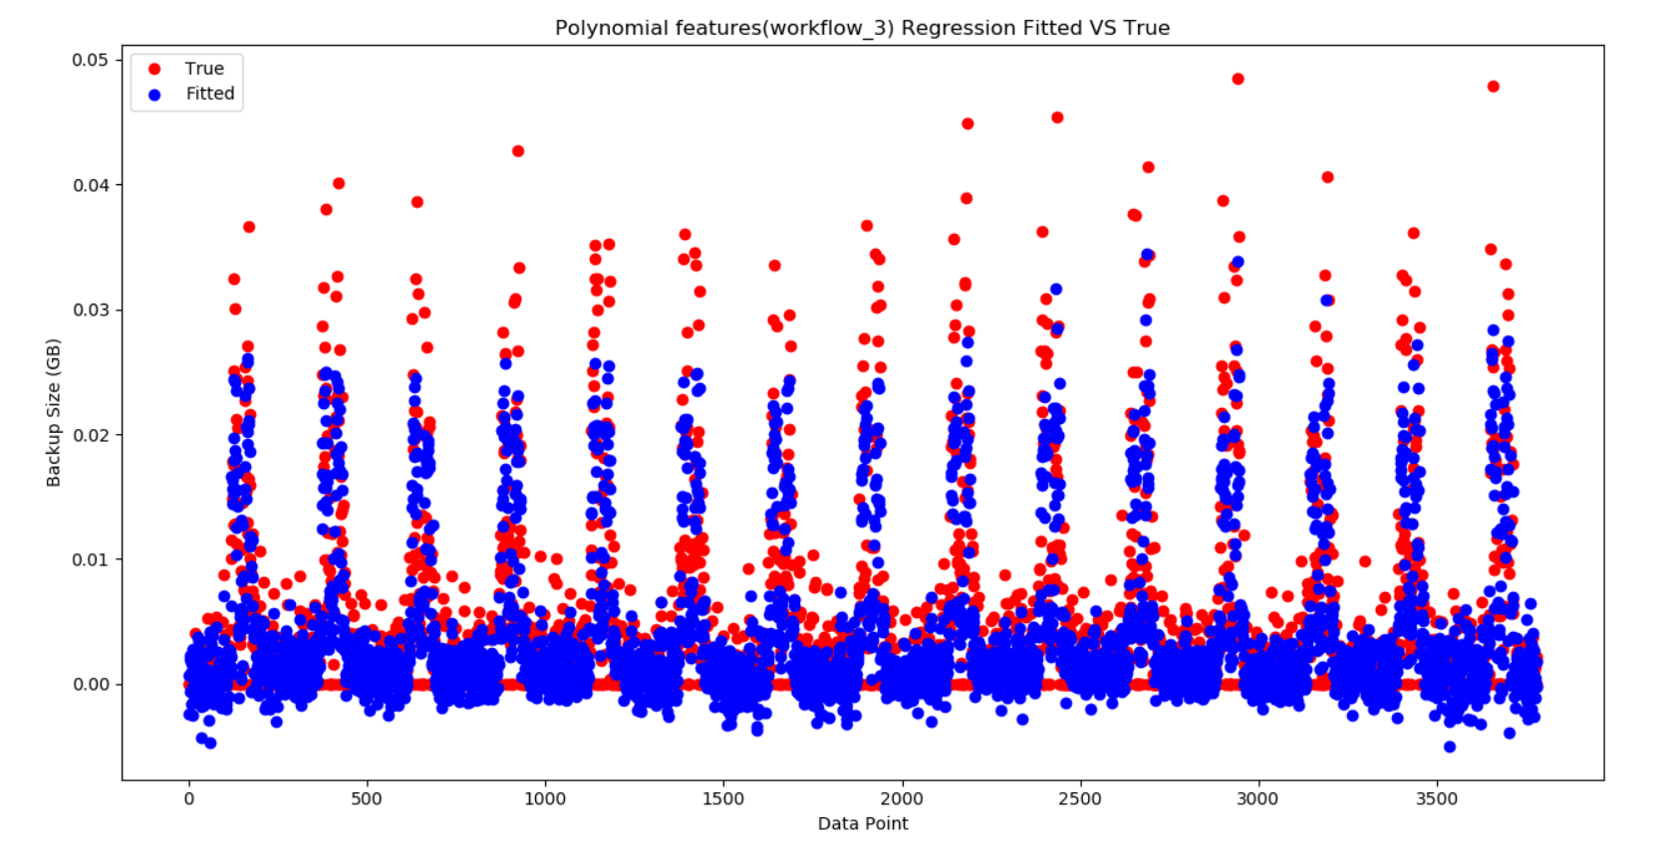

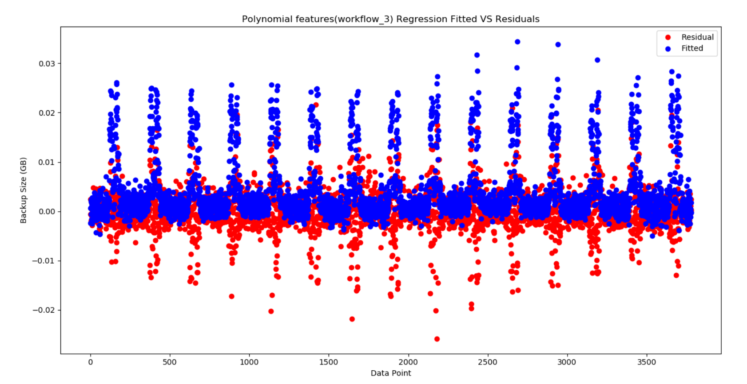

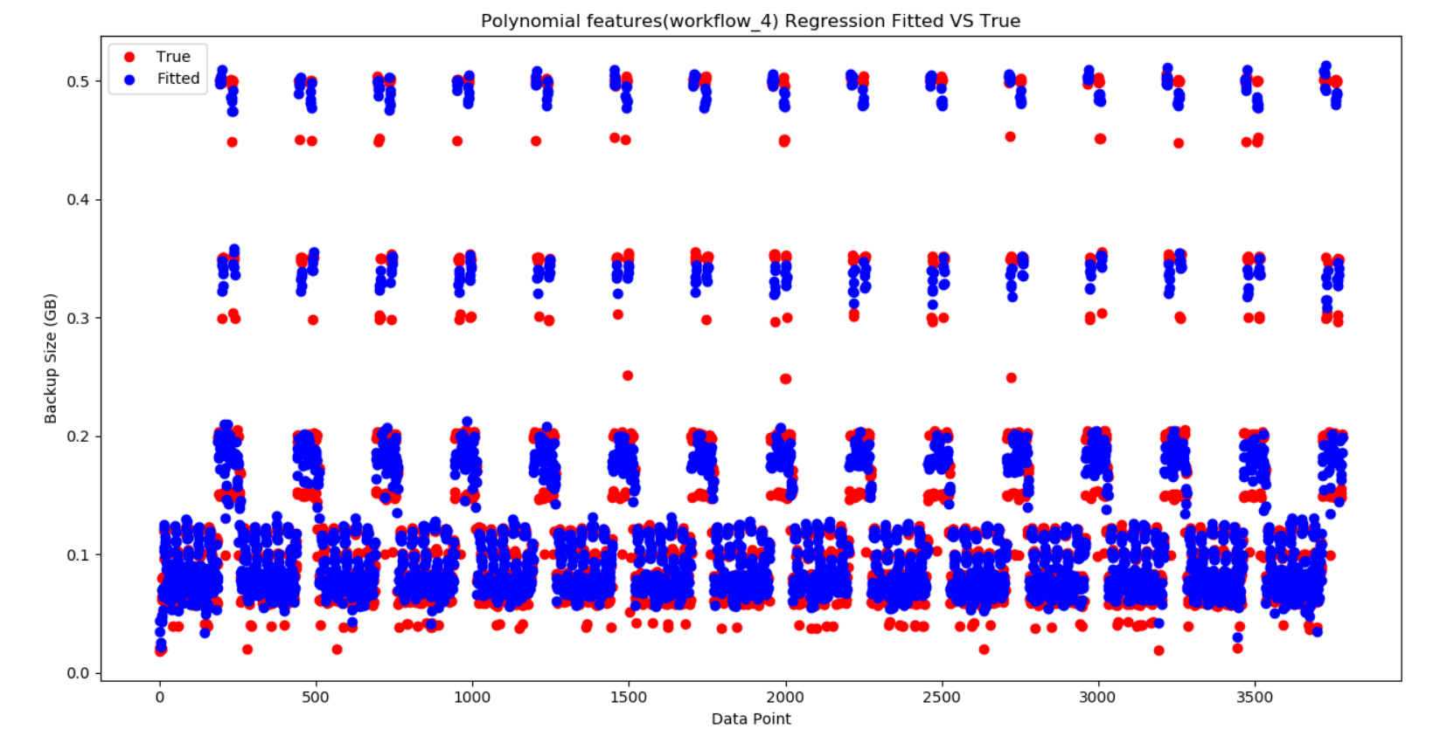

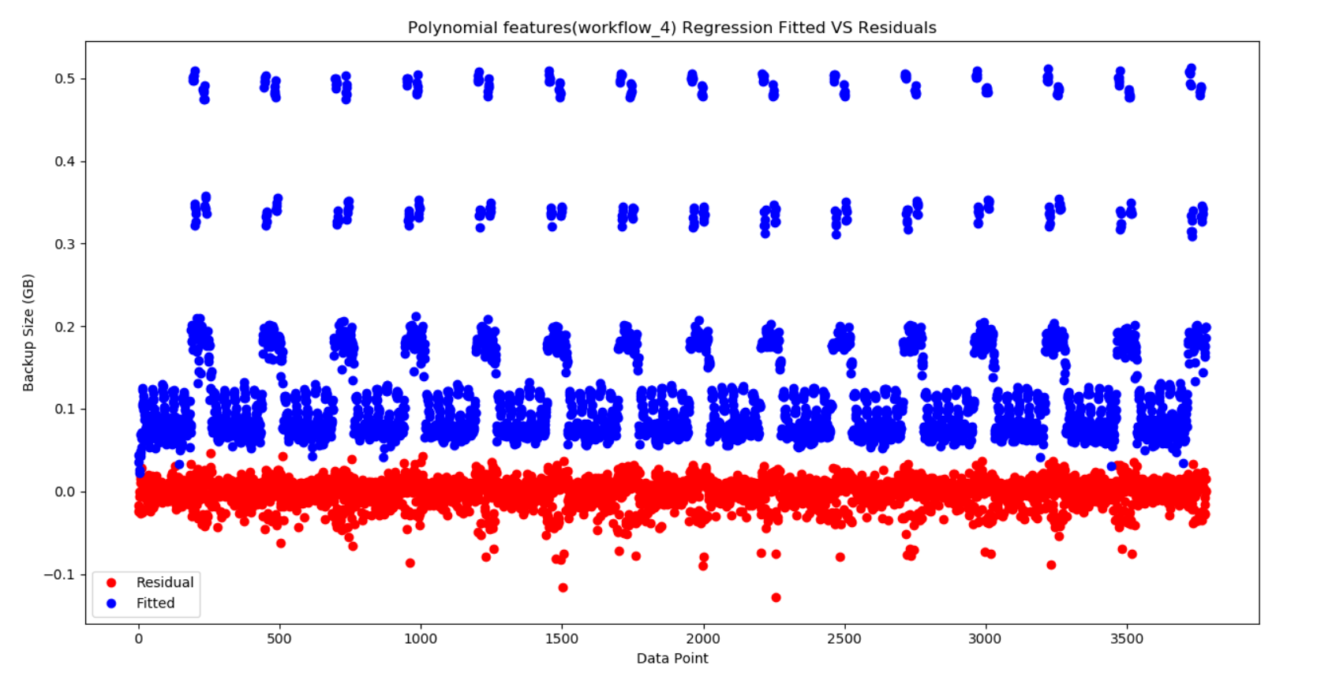

During 10-fold cross validation, 10 different models are trained and tested. The advantage of this technique is that models are trained on different subsets of the dataset. Thus, if the model is overfitting on most of the subsets, then this is a good indication that the model is too complex for the dataset and hence, a simpler model must be trained. As a result, cross-validation helps in detecting overfitting which suggests that a simpler model should be used.

1. k-NN

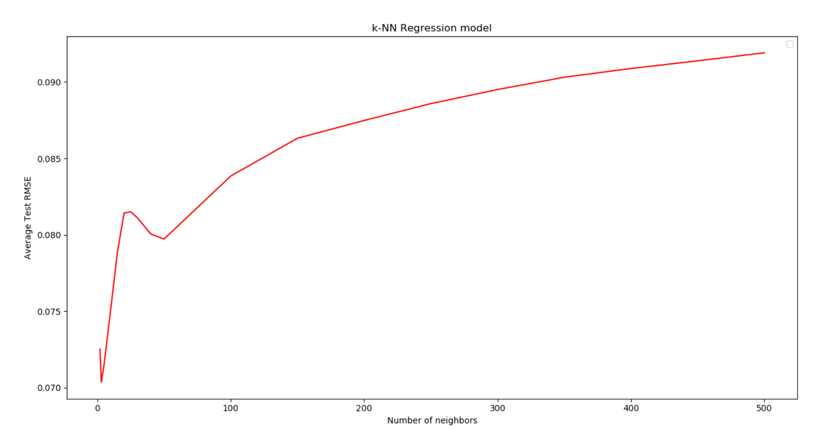

The average Test RMSE is the lowest when # of neighbors = 3.

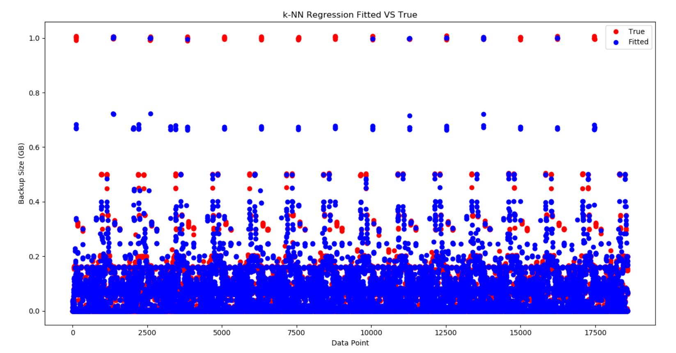

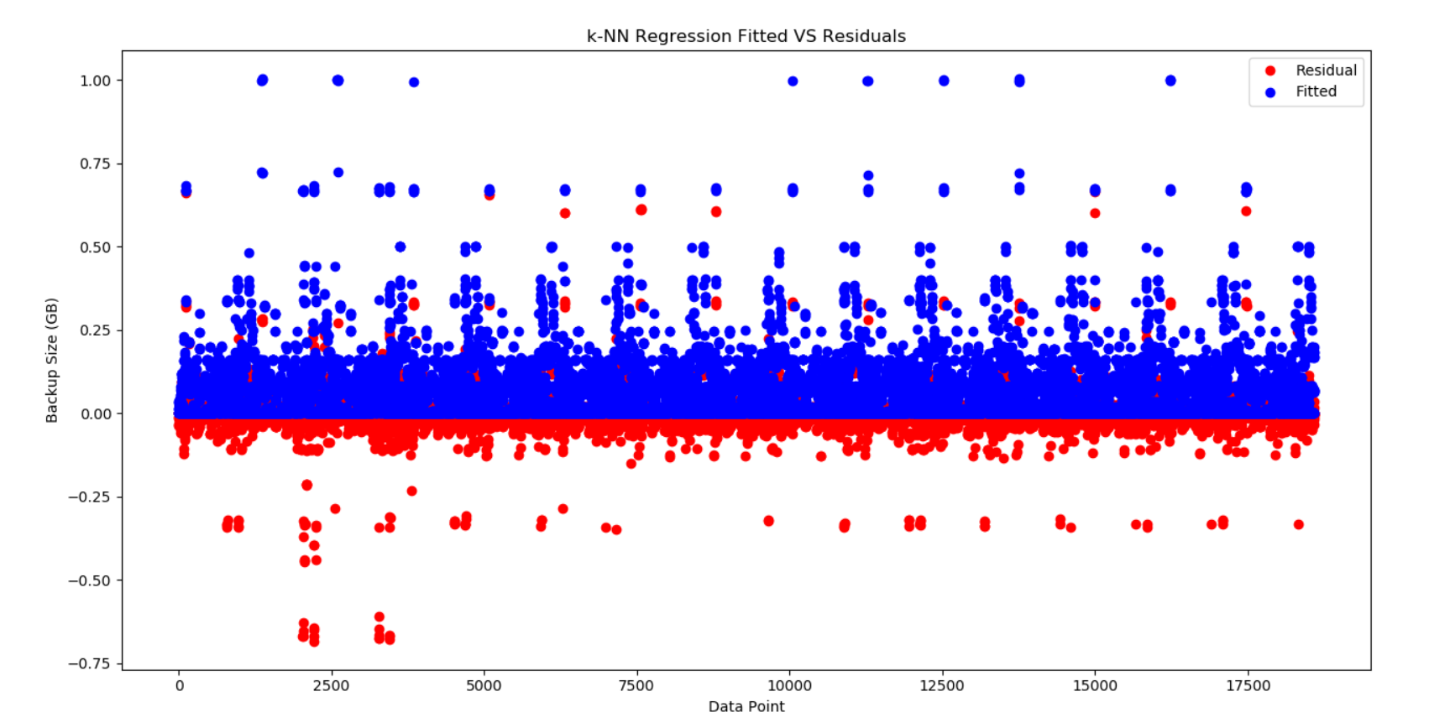

**QUESTION 3:**

The random forest model is the best at handling categorical features. This is because the random forest model decides to split on the most informative node. Since categorical features are discrete, the random forest can select the most informative feature and split on it. The neural network is the best at handling sparse features because it can deal with the non-linearities between the features. On a related note, the k-NN model would be good at handling sparse features if the sparse features were projected on a low-dimensional subspace.

**DATASET 2**

**QUESTION 2:**

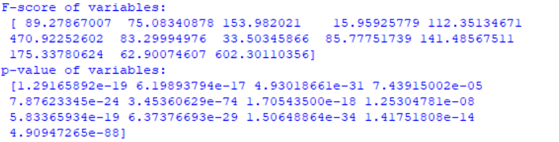

The higher the F-score, the more statistically significant the variable is. This can also be interpreted as the lower the p-value, the more statistically significant the variable is. From the values above, it can be seen that the features ‘RM’ and ‘LSTAT’ are the two most statistically significant variables. The least statistically significant variables are ‘CHAS’ and ‘DIS’. However, it should be noted that strong statistical significance and correlation does not imply strong statistical causation.

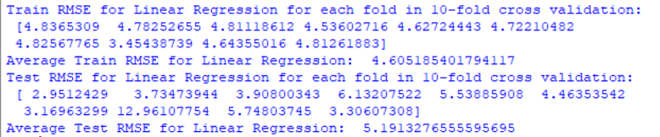

I will use the Test RMSE to determine which is the best estimator. The lowest Test RMSE occurs at fold = 1. Thus, I will choose the estimator that was trained in that fold.

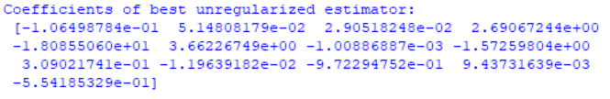

The coefficients of the best unregularized estimator are non-zero. They have varying magnitudes because the magnitudes range from ${10}^{-3}$ to ${10}^{0}$. This means that some coefficients are 1000 times more significant than other coefficients. This makes the estimator unstable. This is a key property of unregularized models.

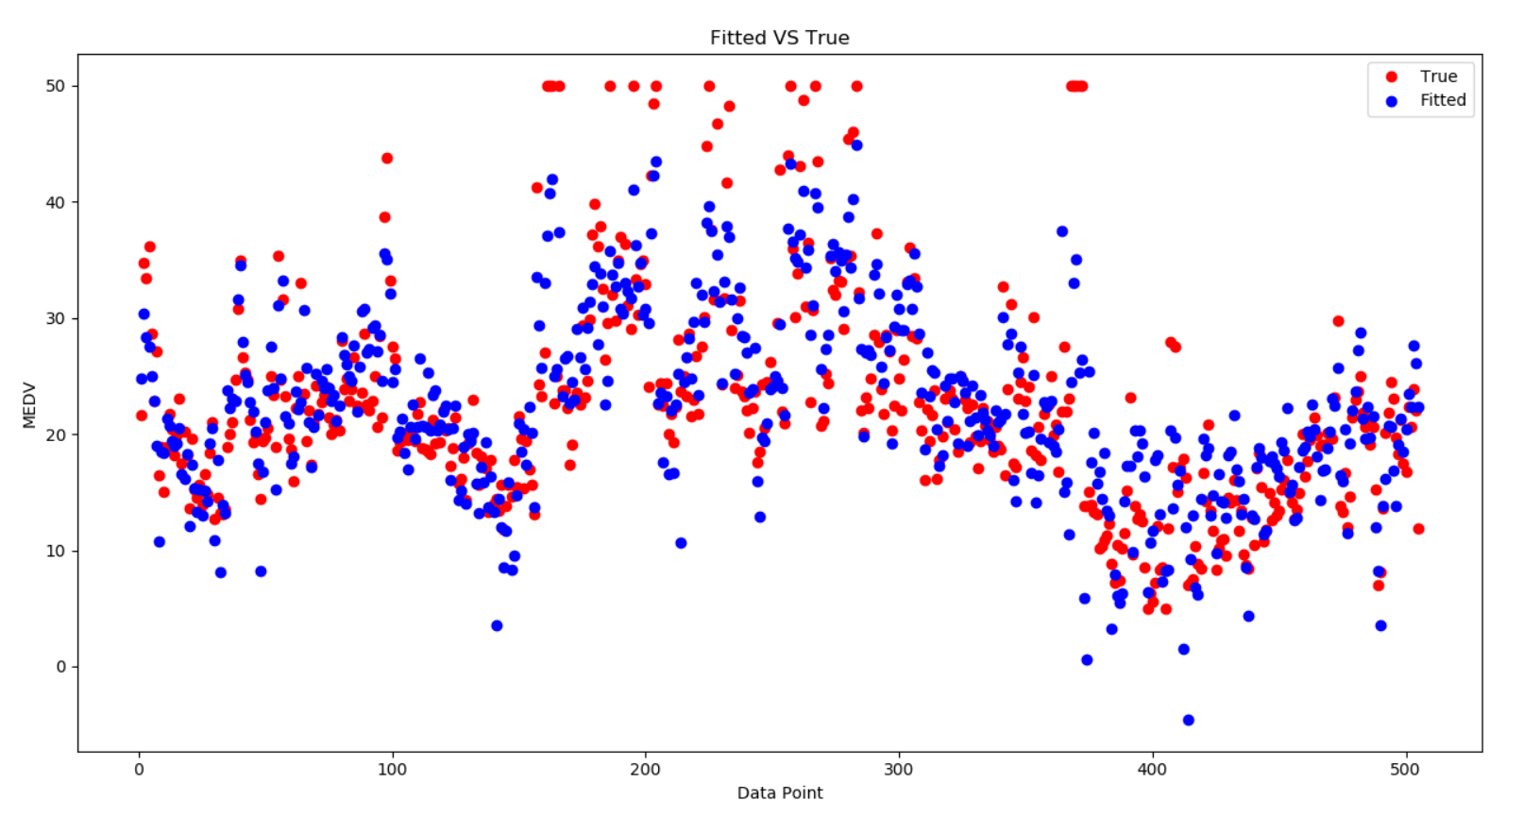

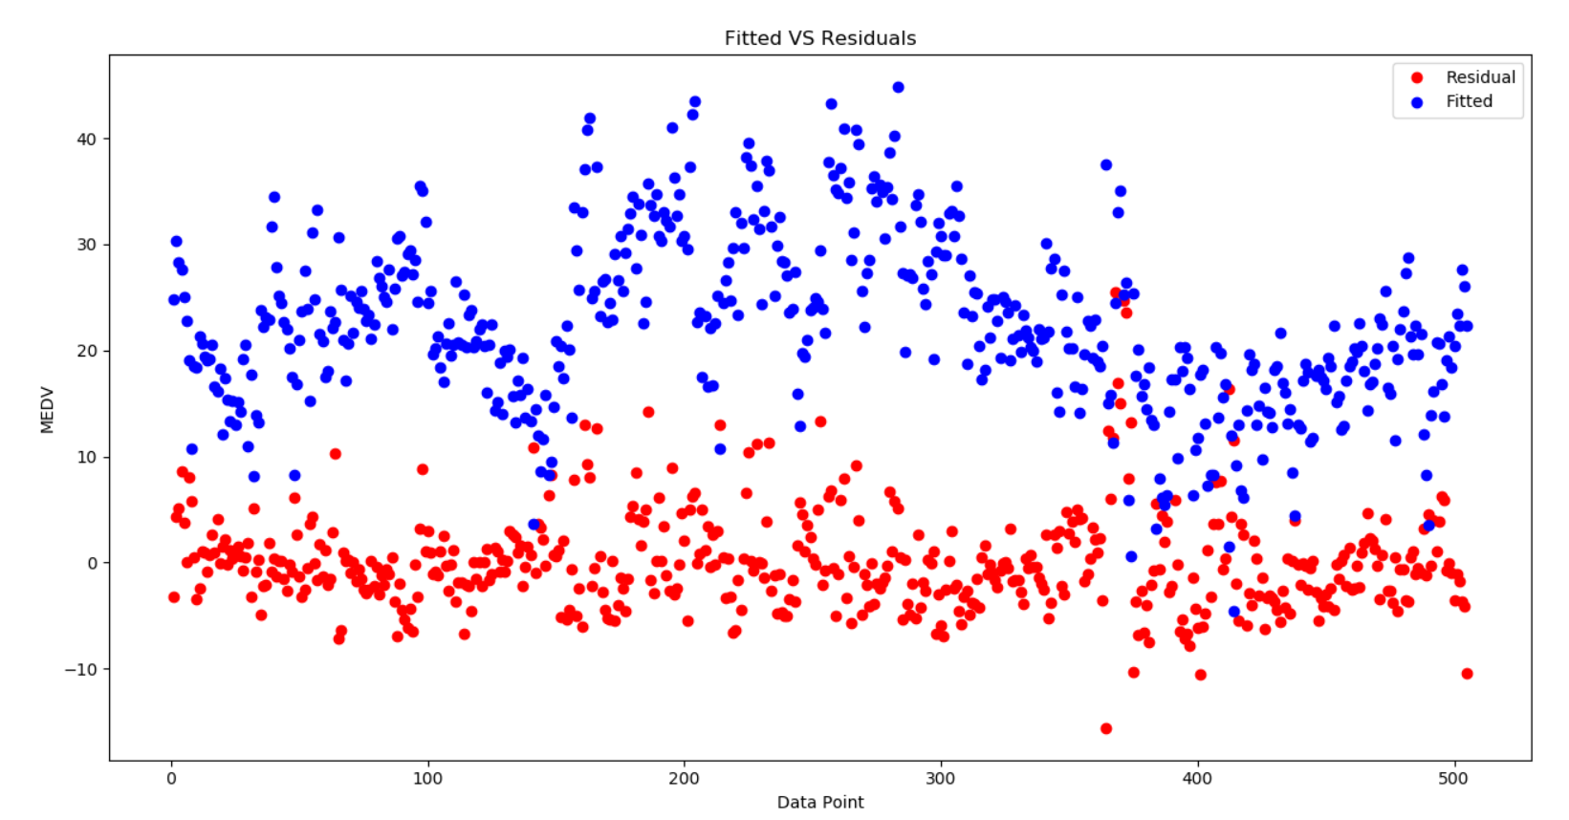

**QUESTION 3:**

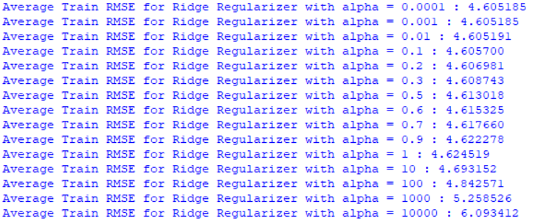

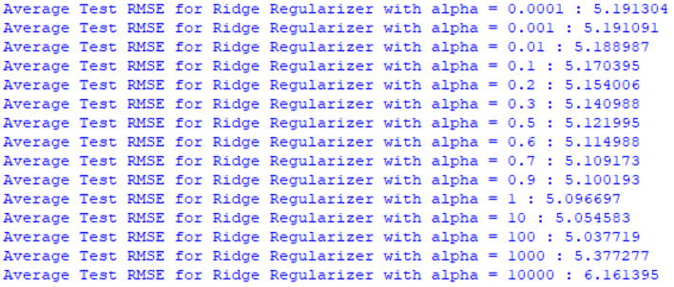

I will use the Test RMSE to determine which is the best estimator. The lowest Test RMSE for Ridge Regularizer occurs at $λ=100$.

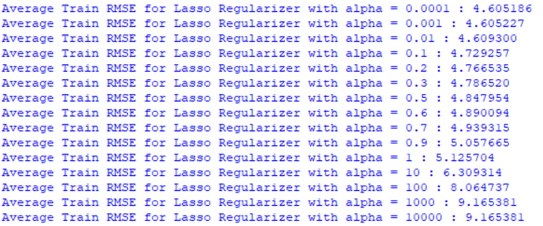

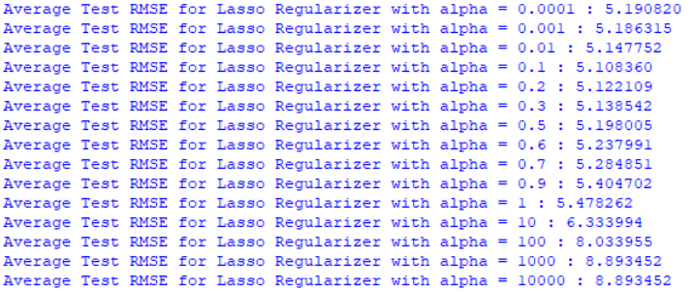

I will use the Test RMSE to determine which is the best estimator. The lowest Test RMSE for Lasso Regularizer occurs at $λ=0.1$.

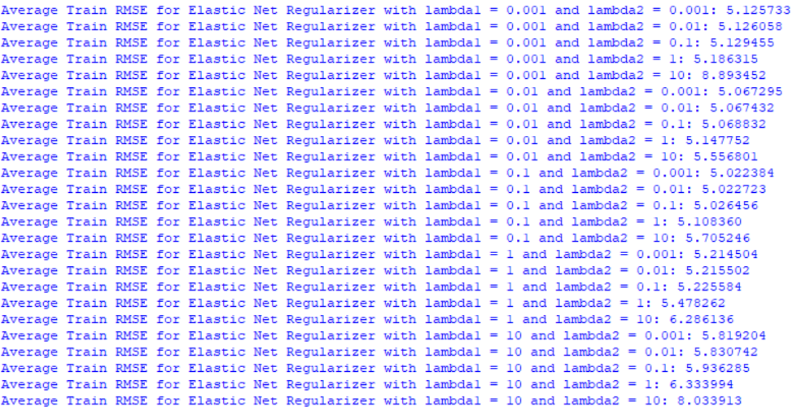

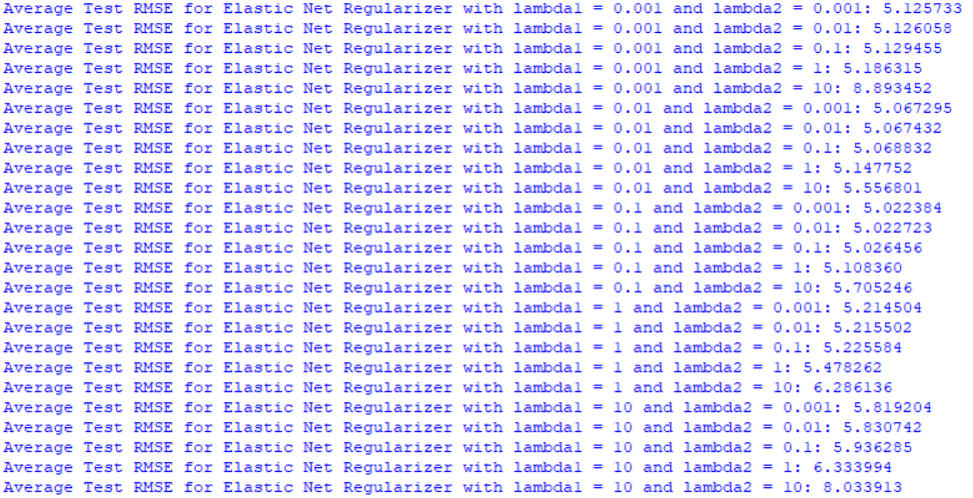

I will use the Test RMSE to determine which is the best estimator. The lowest Test RMSE for Elastic Net Regularizer occurs at $λ_{1}=0.1$ and $λ_{2}=0.001$.

After comparing all the three regularized models, the best regularized model is Elastic Net Regularizer with $λ_{1}=0.1$ and $λ_{2}=0.001$.

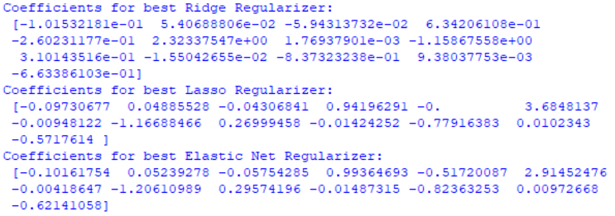

The coefficients of the best Ridge Regularizer are mostly on the order of ${10}^{-1}$. This makes the estimator more stable because a small change in one of the variables will not cause a huge change in the output.

The coefficients of the best Lasso Regularizer are slightly larger and sparser. The L1 penalty works as a feature selection mechanism and thus some variables end up with a coefficient equal to 0. A sparse model tends to have good stable performance.

The coefficients of the Elastic Net Regularizer are mostly smaller than Lasso regularizer but bigger than Ridge regularizer.

A comparison of the coefficients of all the regression models is presented below. They are on the same orders of magnitude and absolute value. The coefficients of Lasso Regularizer are the closest in magnitude to the coefficients of the unregularized model.

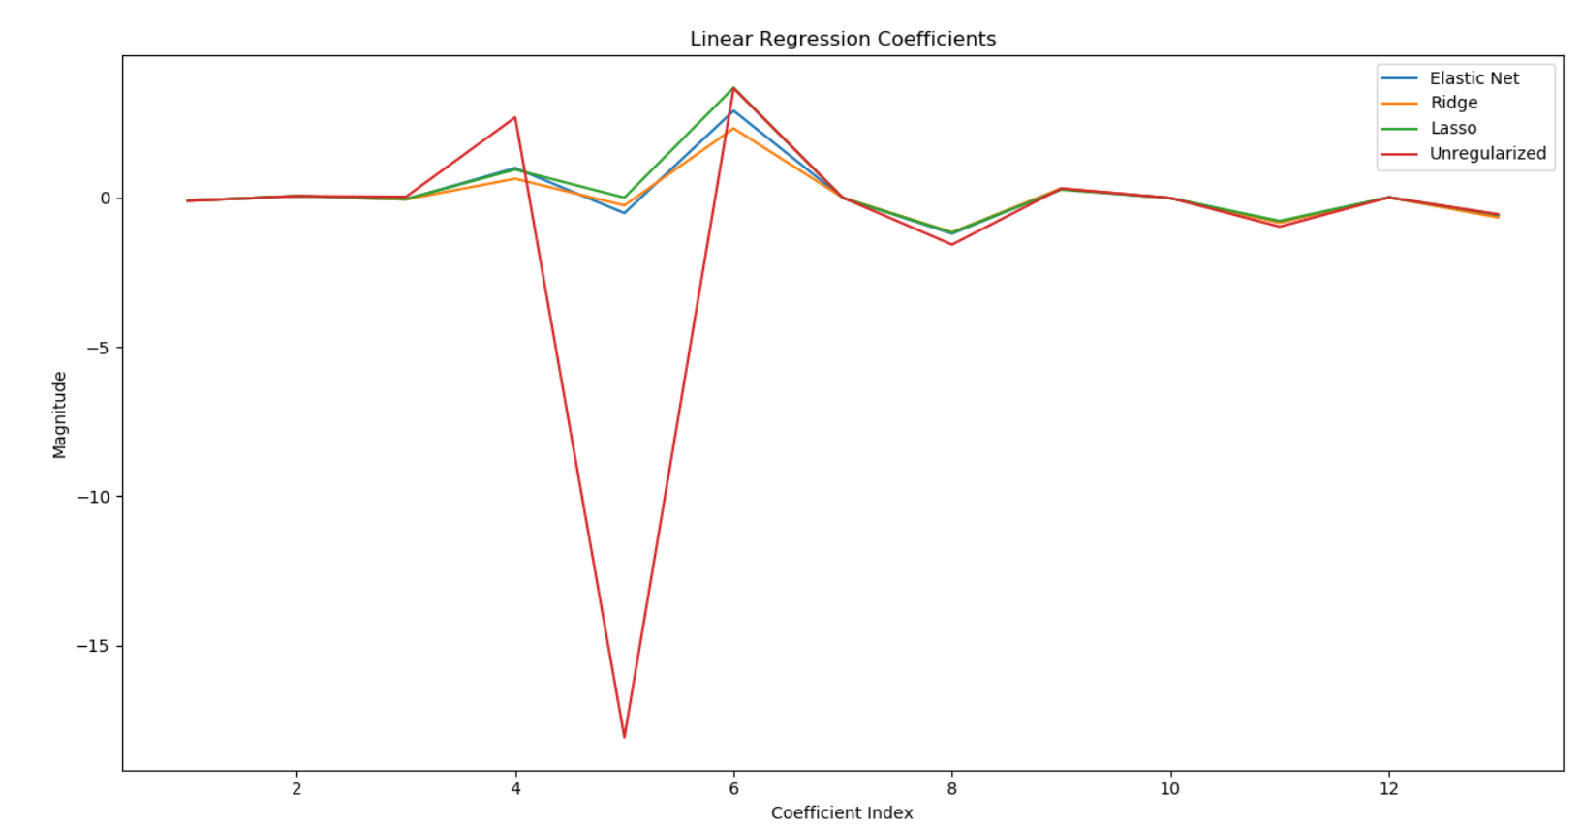

**DATASET 3**

**QUESTION 1:**

Feature Encoding-

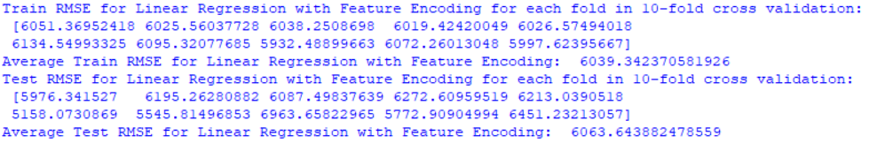

I will use the Test RMSE to determine which is the best estimator. The lowest Test RMSE occurs at fold = 6. Thus, I will choose the estimator that was trained in that fold.

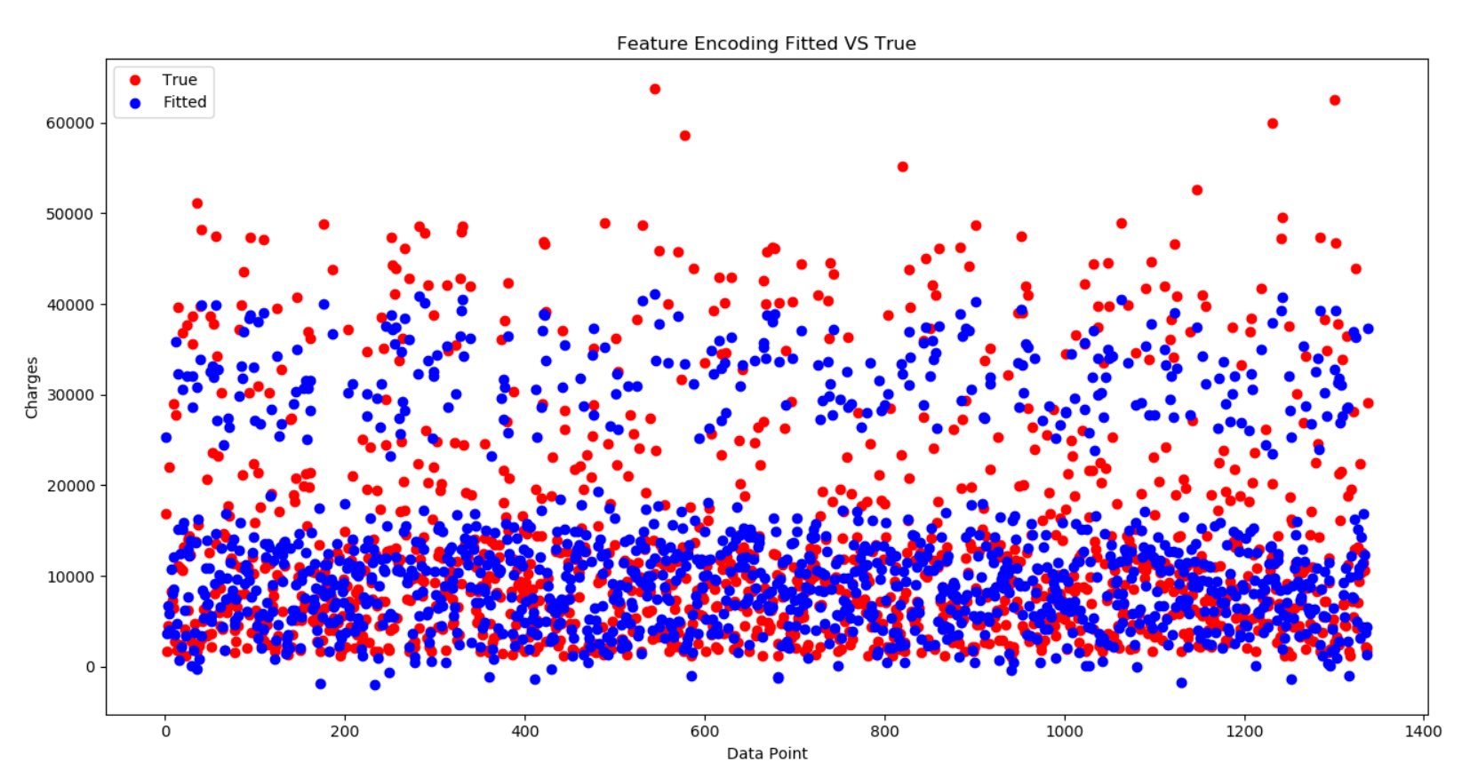

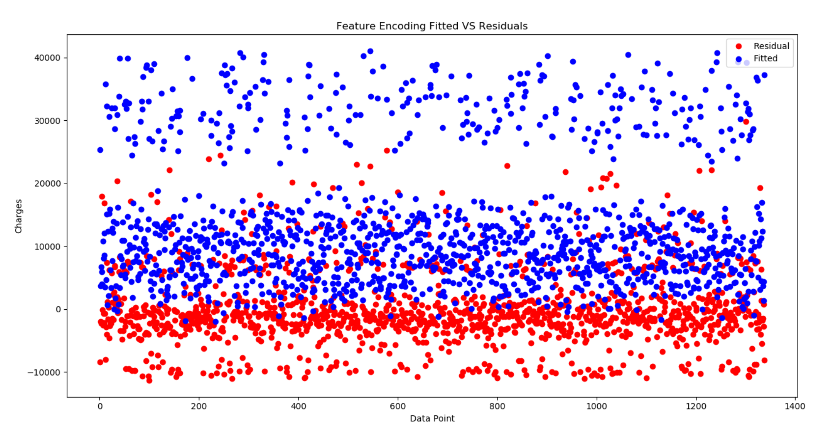

Standardization-

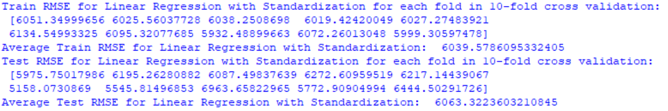

I will use the Test RMSE to determine which is the best estimator. The lowest Test RMSE occurs at fold = 6. Thus, I will choose the estimator that was trained in that fold.

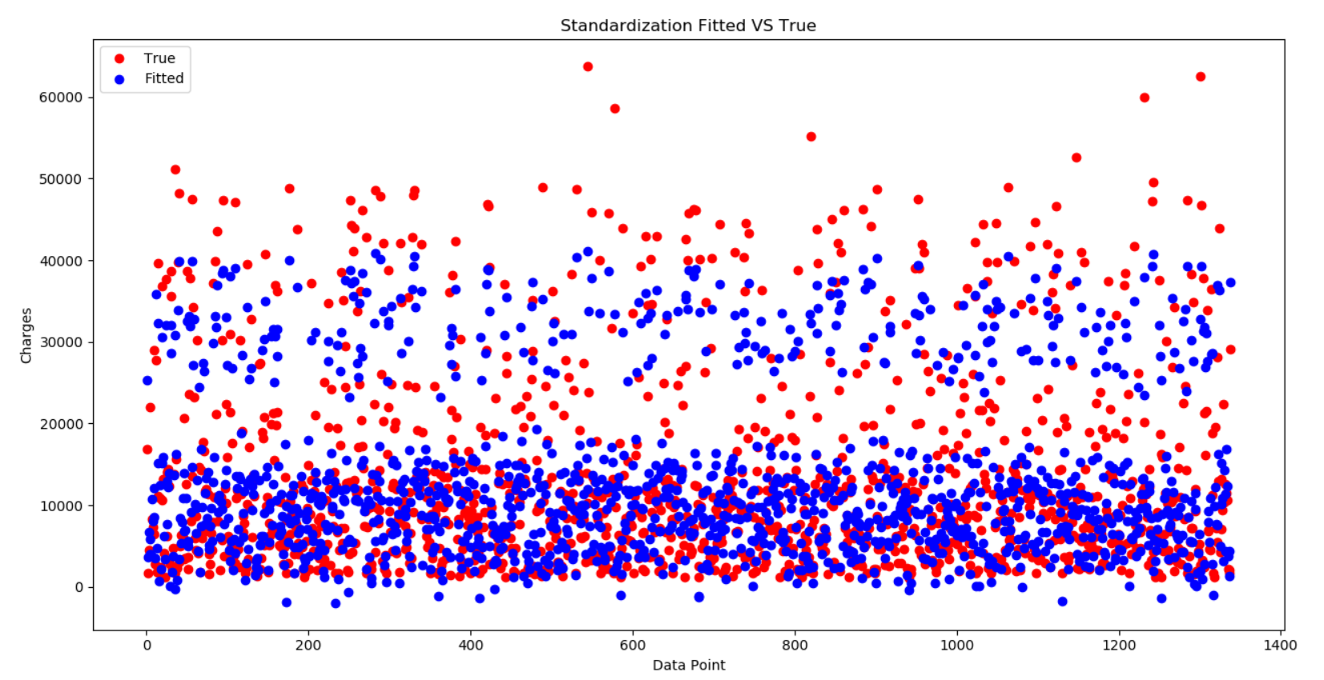

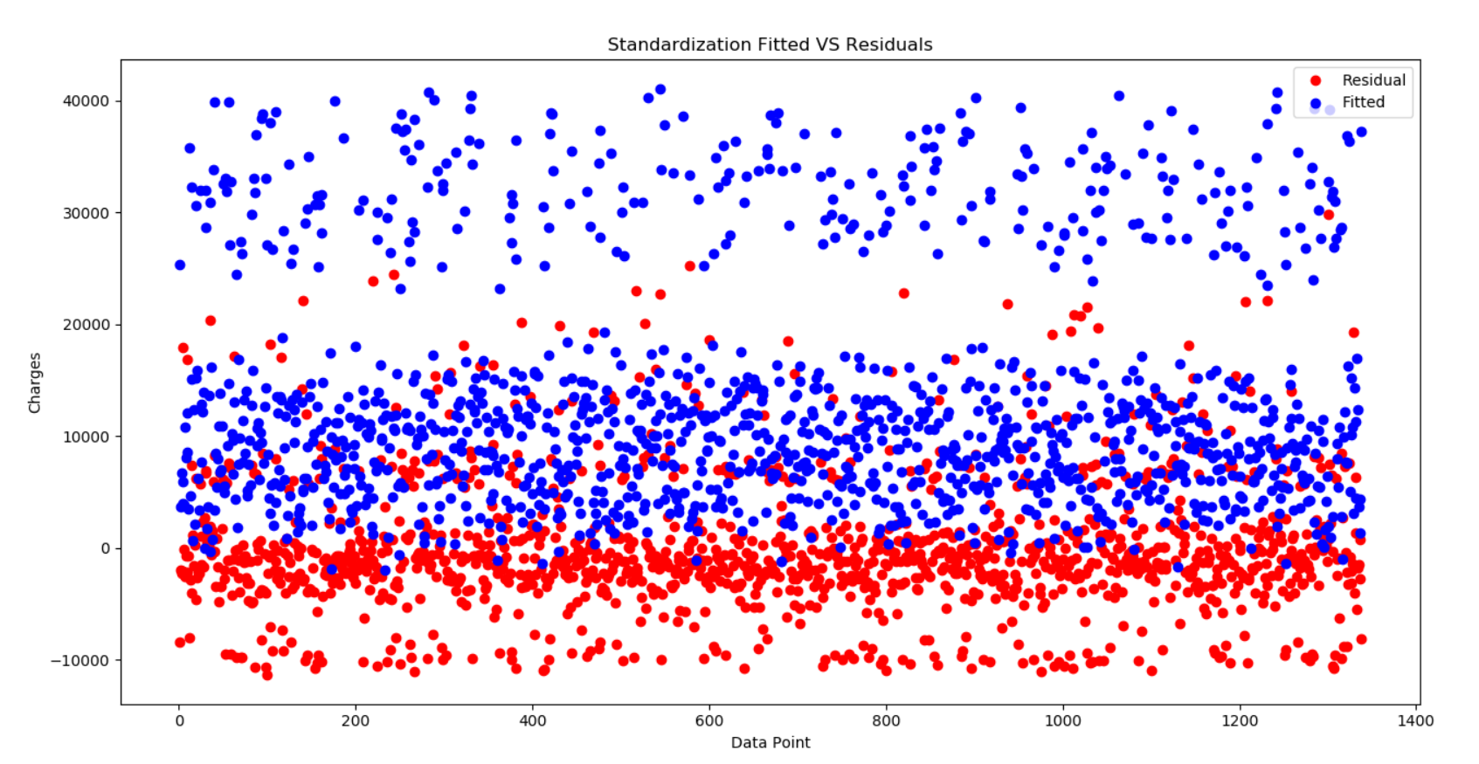

Dividing into 3 ranges-

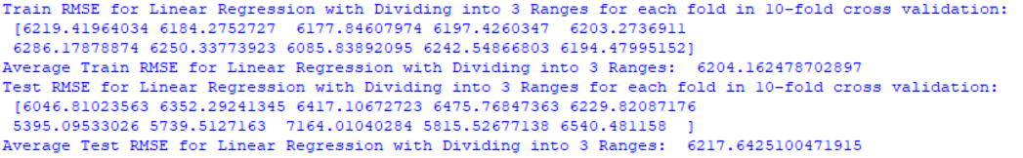

I will use the Test RMSE to determine which is the best estimator. The lowest Test RMSE occurs at fold = 6. Thus, I will choose the estimator that was trained in that fold.

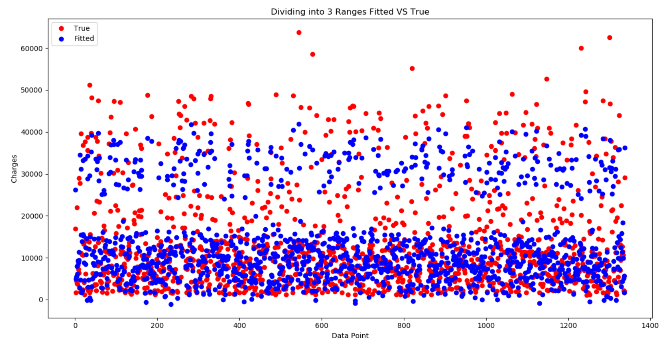

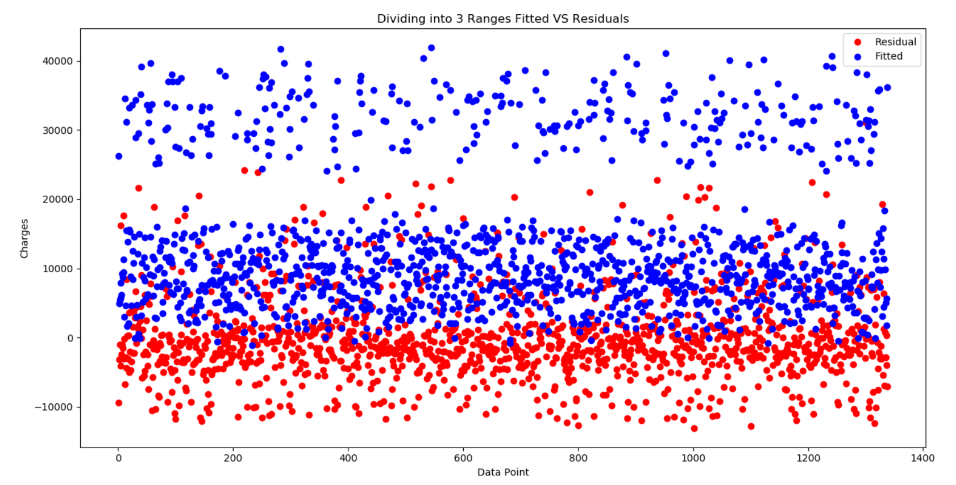

**QUESTION 2:**

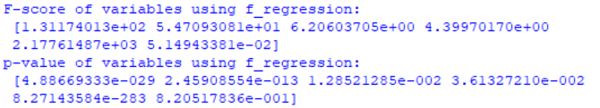



From the values above, it can be seen that the two most statistically significant features are ‘ft1’ and ‘ft5’.

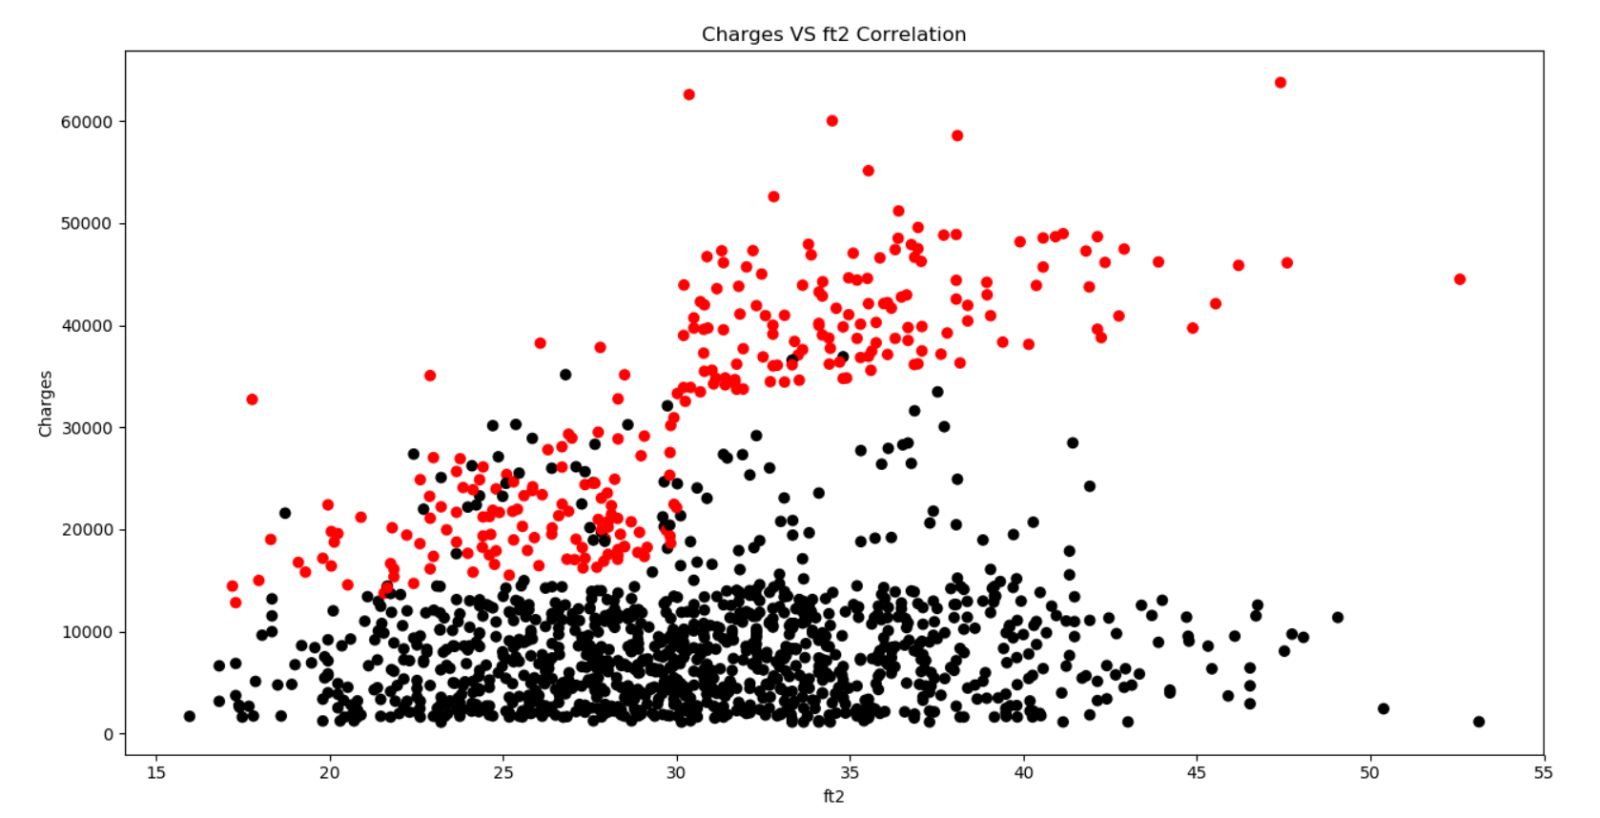

The red points correspond to the ‘yes’ values in ft5. The black points correspond to the ‘no’ values in ft5. Roughly speaking, there is a linear relationship. Moreover, the coloring of the data points shows us two different clusters.

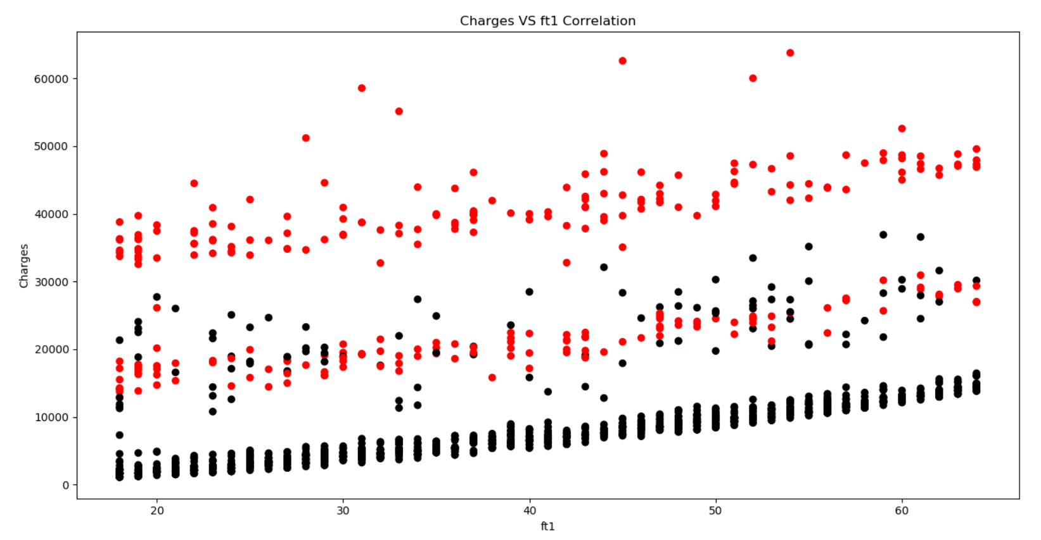

The red points correspond to the ‘yes’ values in ft5. The black points correspond to the ‘no’ values in ft5. There is a small positive linear relationship. There, the coloring of the data points shows us that there are 3 different clusters. This implies that there is a latent factor in the data that is not explicitly included in the dataset.

**QUESTION 3:**

I chose the Standardization feature preprocessing method because it produced the best results previously.

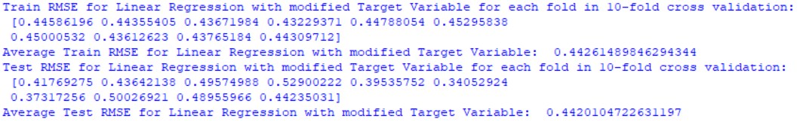

The results for average train and test RMSE are in log space. Thus, the values presented above are of the form $\log\left(y_{actual}\right)-log⁡(y_{predicted})$.

I will use the Test RMSE to determine which is the best estimator. The lowest Test RMSE occurs at fold = 6. Thus, I will choose the estimator that was trained in that fold.

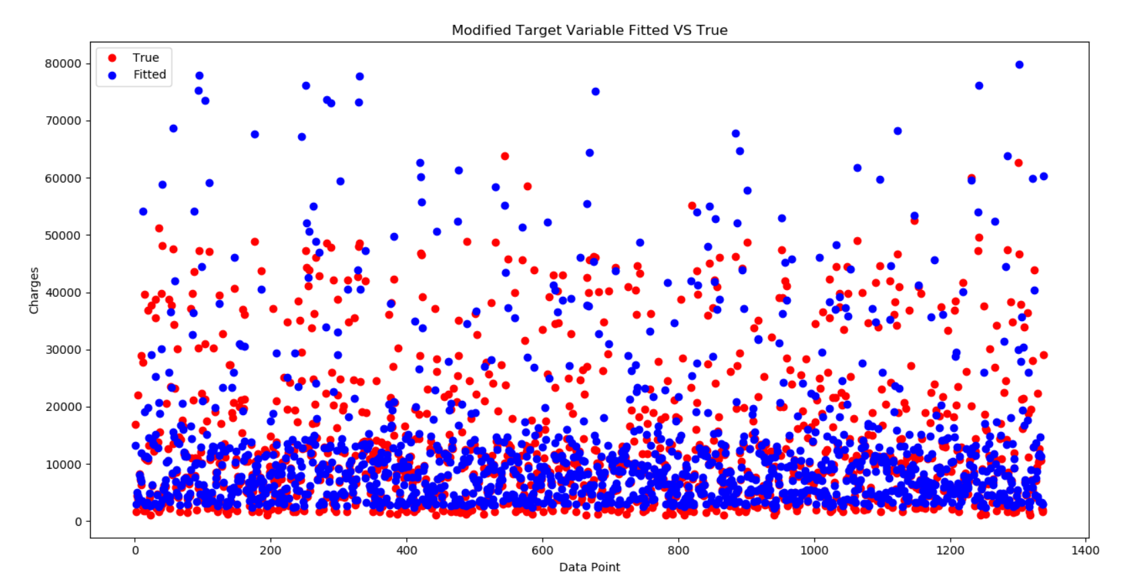

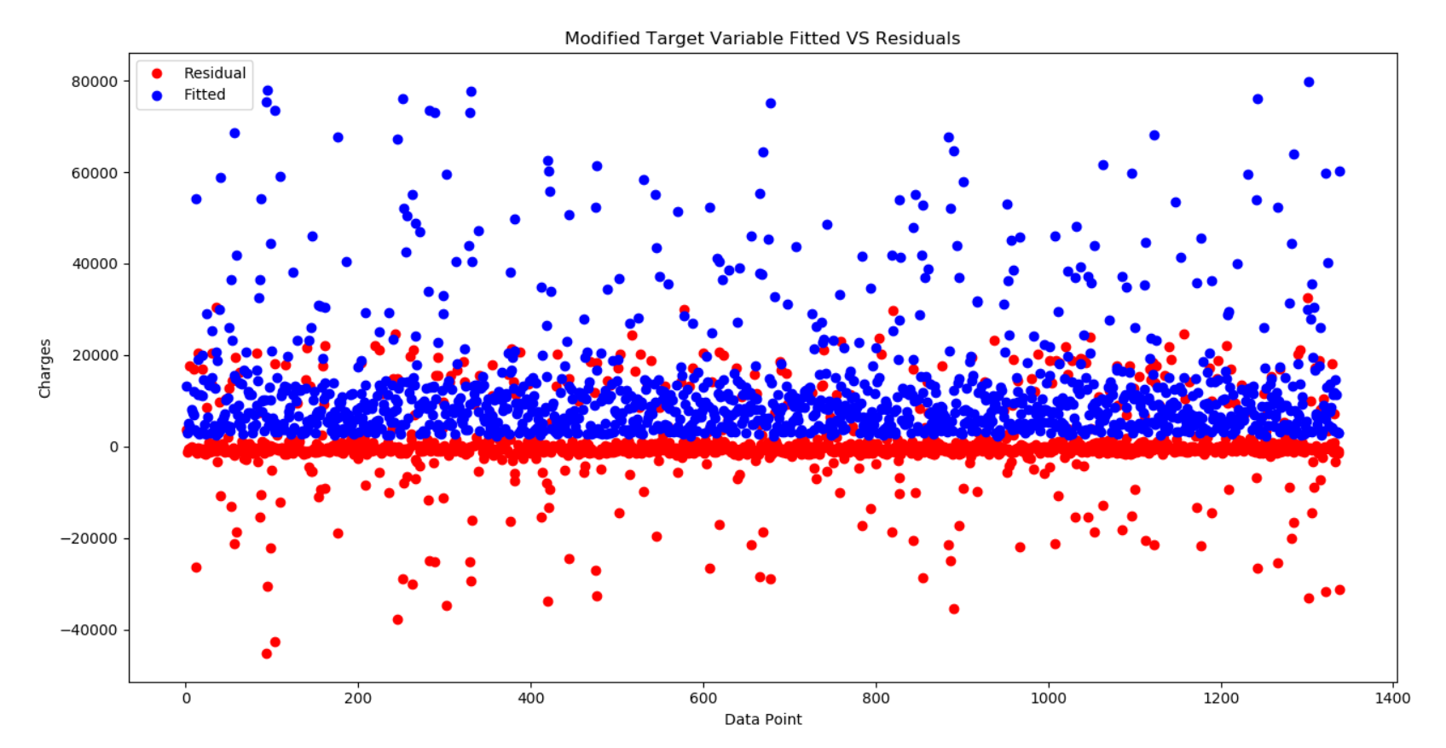

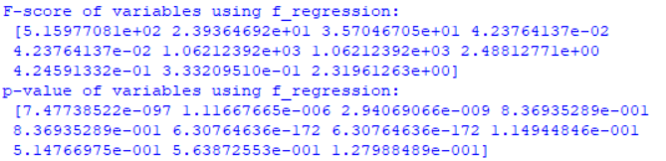



The 6th and 7th features are the most statistically significant. However, these features are one-hot encoded and thus correspond to one categorical feature which is ‘ft5’. The next most statistically significant feature is the 1st feature. Thus, the two most statistically significant variables are ‘ft1’ and ‘ft5’. These findings are the same as those in QUESTION 2.

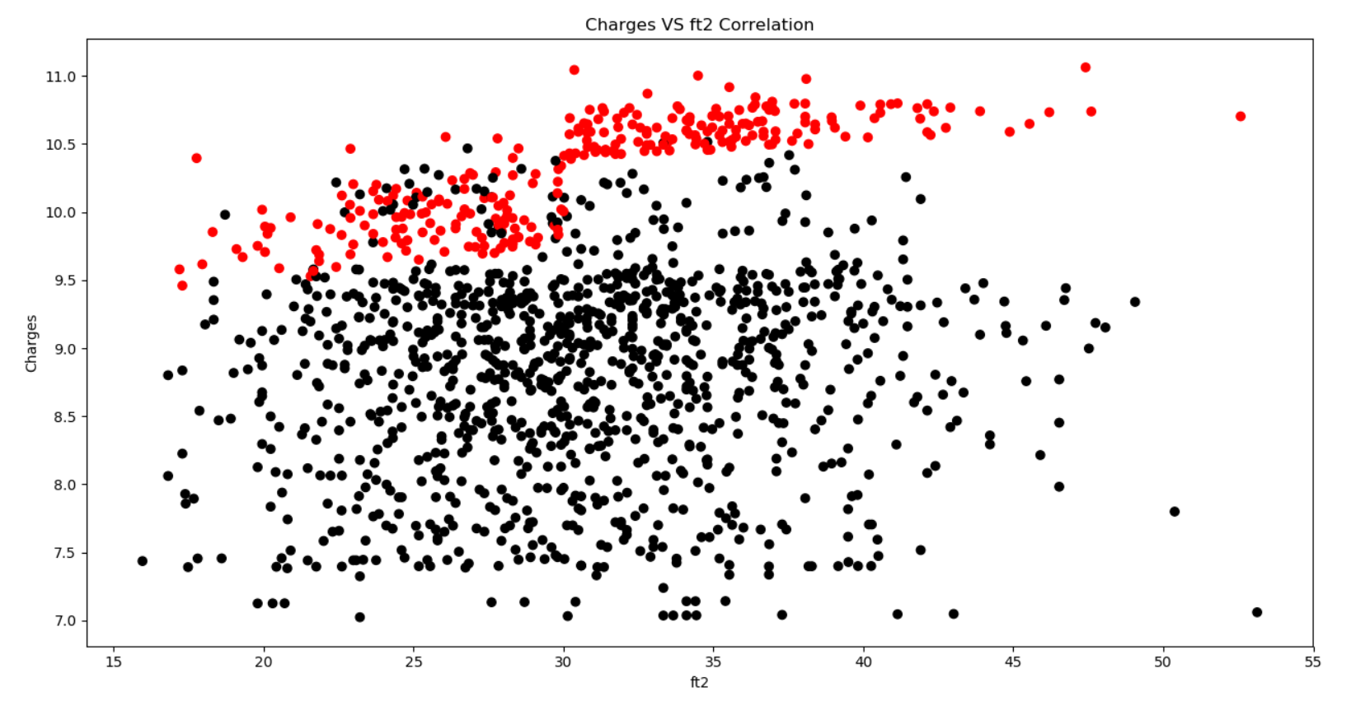

The red points correspond to the ‘yes’ values in ft5. The black points correspond to the ‘no’ values in ft5.

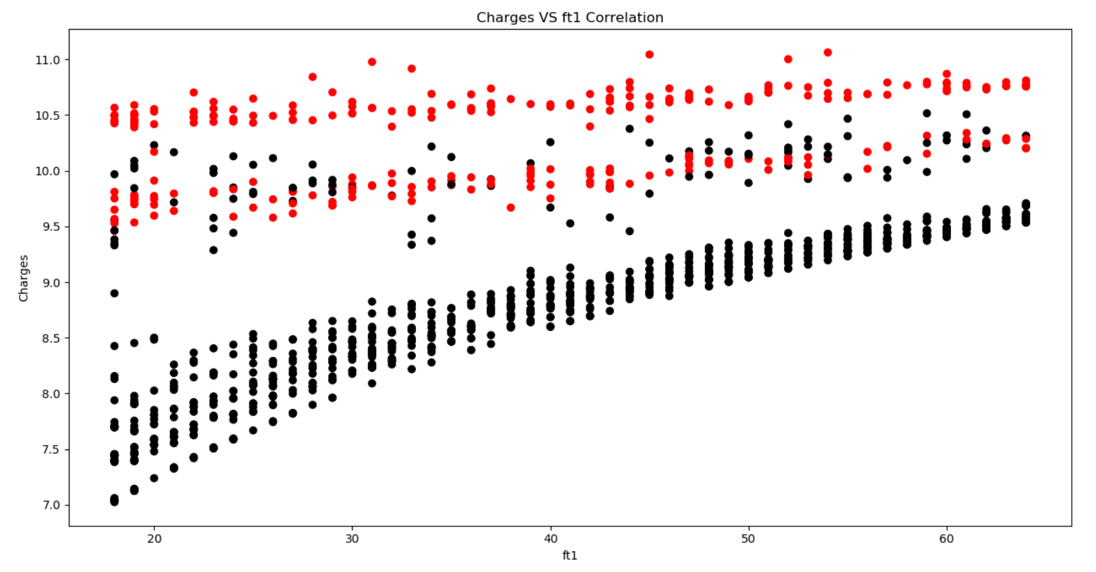

The red points correspond to the ‘yes’ values in ft5. The black points correspond to the ‘no’ values in ft5. There is a linear relationship.

**QUESTION 4:**

1. Feature encoding

I tried polynomial features for feature encoding.

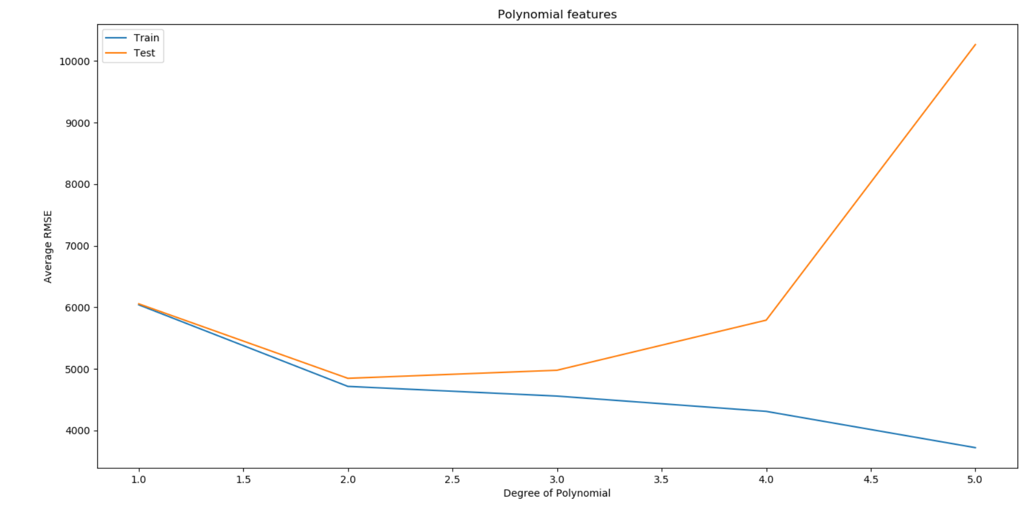

It can be seen that the test RMSE starts to increase after the degree of polynomial goes above 2. This shows that the model is overfitting. Thus, the optimal degree of polynomial features is 2. Also, the lowest test RMSE is 4846. This is better than using Standardization for feature encoding. Thus, polynomial features improve model performance.

1. Model experimentation







It can be seen that neural networks with 600 neurons with a ReLU activation function improve the performance when the data is passed through the Standardization feature preprocessing method.

**Conclusion**

The best preprocessing technique seems to be Standardization. After doing the bonus questions, adding polynomial features as feature preprocessing gives the lowest test RMSE.

Dataset 1 and 3 contained both categorical and numerical features. Dataset 2 almost purely contained numerical features.

The random forest model is the best at handling categorical features. This is because the random forest model decides to split on the most informative node. Since categorical features are discrete, the random forest can select the most informative feature and split on it. The neural network is the best at handling sparse features because it can deal with the non-linearities between the features. On a related note, the k-NN model would be good at handling sparse features if the sparse features were projected on a low-dimensional subspace.

The random forest model is more suitable for categorical data. Neural networks and k-NN are good at both categorical and numerical. However, neural networks can handle sparsity whereas k-NN has trouble with sparse data in high dimensions. Linear regression works better with numerical data rather than categorical data.